**Spark + Scala Notes**

**To logging to Spark – Log into Hadoop and type in the command Spark-Shell**

**Below is sample file BNK01.txt in Hadoop**

**val users = sc.textFile("BNK01.txt").map(line => line.split("\\W")).take(10);**

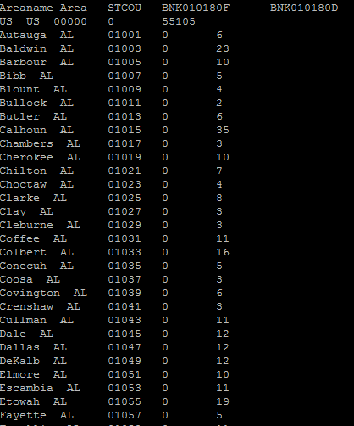

**Example : Difference between FlatMap and Map with Split function**

**flatMap(Split(“****\\W****”) function :** Splits file by words ie adds comma after every word.

**val users = sc.textFile("BNK01.txt").flatMap(line => line.split("\\W")).take(10);**

Output: The entire data from file is split with comma after every word and represented as one array. Here take(10) will display 10 words

users: Array[String] = Array(Areaname, Area, STCOU, BNK010180F, BNK010180D, US, "", US, 00000, 0)

**map(Split(“****\\W****”) function :** Splits file by words ie adds comma after every word.

**val users = sc.textFile("BNK01.txt").map(line => line.split("\\W")).take(10);**

Output: Every line/record from the file is split with comma after every word and represented as one array. Here take(10) will display 10 lines

**users: Array[Array[String]] = Array(Array(Areaname, Area, STCOU, BNK010180F, BNK010180D), Array(US, "", US, 00000, 0, 55105), Array(Autauga, "", AL, 01001, 0, 6), Array(Baldwin, "", AL, 01003, 0, 23), Array(Barbour, "", AL, 01005, 0, 10), Array(Bibb, "", AL, 01007, 0, 5), Array(Blount, "", AL, 01009, 0, 4), Array(Bullock, "", AL, 01011, 0, 2), Array(Butler, "", AL, 01013, 0, 6), Array(Calhoun, "", AL, 01015, 0, 35))**

**map(Split(“****\\t****”).map(Fields) function :** Splits file by tab ie adds comma after a tab and displays fields specified. In this example, two fields are displayed

**val users = sc.textFile("BNK01.txt").map(line => line.split('\t')).map(fields => (fields(0),fields(1))).take(10);**

Output:

**users: Array[(String, String)] = Array((Areaname Area,STCOU), (US US,00000), (Autauga AL,01001), (Baldwin AL,01003), (Barbour AL,01005), (Bibb AL,01007), (Blount AL,01009), (Bullock AL,01011), (Butler AL,01013), (Calhoun AL,01015))**

**One difference between Map and FlatMap when we further process:**

**Flat Map :**

1. **val parsedRDD = rdd.flatMap { line => line.split("""\s+""")}.take(10);**

**Note : Output is entire file in single array**

res6: Array[String] = Array(en, Suspensory_ligament, 3, 22740, en, Suspensory_ligament_of_duodenum, 1, 17535, en, Suspensory_ligament_of_eyeball)

1. **val parsedRDD = rdd.flatMap { line => line.split("""\s+""")}.map(word => (word,1))**

Here when u further put a map, word is every element from the last array. Ie

res5: Array[(String, Int)] = Array((en,1), (Suspensory_ligament,1), (3,1), (22740,1), (en,1), (Suspensory_ligament_of_duodenum,1), (1,1), (17535,1), (en,1), (Suspensory_ligament_of_eyeball,1))

**Map :**

**val parsedRDD = rdd.map (line => line.split("""\s+""")).take(10);**

**Note : Output is array of array, where every line is array**

parsedRDD: Array[Array[String]] = Array(Array(en, Suspensory_ligament, 3, 22740), Array(en, Suspensory_ligament_of_duodenum, 1, 17535), Array(en, Suspensory_ligament_of_eyeball, 1, 10302), Array(en, Suspensory_ligament_of_penis, 2, 26984), Array(en, Susperia, 1, 12662), Array(en, Suspicion, 3, 26349), Array(en, Suspicion_%28manga%29, 1, 12257), Array(en, Suspicion_(1941_film), 9, 268177), Array(en, Suspicion_(R.E.M._song), 2, 27256), Array(en, Suspicion_(Terry_Stafford_song), 3, 39401))

**val parsedRDD = rdd.map (line => line.split("""\s+""")).map(word => (word(0),word(2).toInt)).take(10)**

Here when u further put a map, word is every element from the last array. Ie a line. And word(0) and Word(2) is first word and third word from every line.

Array[(String, Int)] = Array((en,3), (en,1), (en,1), (en,2), (en,1), (en,3), (en,1), (en,9), (en,2), (en,3))

The answer is the same as in other functional languages like Scala. flatMap = map + flatten. map expresses a one-to-one transformation that transforms each element of a collection (like an RDD) into one element of the resulting collection. flatMap expresses a one-to-many transformation that transforms each element to 0 or more elements. However the result is not a collection of collections; it's flattened by concatenating the results into the final collection.

**Word Count using ReduceByKey and GroupByKey**

val words = Array("one", "two", "two", "three", "three", "three")

val wordPairsRDD = sc.parallelize(words).map(word => (word, 1))

val wordCountsWithReduce = wordPairsRDD.reduceByKey(_ + _).collect()

or

val wordCountsWithGroup = wordPairsRDD.groupByKey().map(t => (t._1, t._2.sum)).collect();

val wordCountsWithGroup = wordPairsRDD.groupByKey().collect();

**Output:** Array[(String, Iterable[Int])] = Array((four,CompactBuffer(1)), (two,CompactBuffer(1, 1, 1)), (one,CompactBuffer(1, 1, 1, 1)), (three,CompactBuffer(1, 1, 1)))

**CombineByKey**

val rdd = sc.parallelize(List(

("A", 3), ("A", 9), ("A", 12), ("A", 0), ("A", 5),("B", 4),

("B", 10), ("B", 11), ("B", 20), ("B", 25),("C", 32), ("C", 91),

("C", 122), ("C", 3), ("C", 55)), 2)

rdd.combineByKey(

(x:Int) => (x, 1), //Create Combiner

(acc:(Int, Int), x) => (acc._1 + x, acc._2 + 1), //Merge Value

(acc1:(Int, Int), acc2:(Int, Int)) => (acc1._1 + acc2._1, acc1._2 + acc2._2))

//MergeCombiners

First, createCombiner creates the initial value (combiner) for a key's first encounter on a partition if one is not found --> (firstValueEncountered, 1). So, this is merely initializing a tuple with the first value and a key counter of 1.

Then, mergeValue is triggered only if a combiner (tuple in our case) has already been created for the found key on this partition --> (existingTuple._1 + subSequentValue, existingTuple._2 + 1). This adds the existing tuple's value (in the first slot) with the newly encountered value and takes the existing tuple's counter (in the second slot) and increments it. So, we are

Then, mergeCombiner takes the combiners (tuples) created on each partition and merges them together --> (tupleFromPartition._1 + tupleFromPartition2._1, tupleFromPartition1._2 + tupleFromPartition2._2). This is merely adding the values from each tuple together and the counters together into one tuple.

Then, let's break up a subset of your data into partitions and see it in action:

("A", 3), ("A", 9), ("A", 12),("B", 4), ("B", 10), ("B", 11)

Partition 1

A=3 --> createCombiner(3) ==> accum[A] = (3, 1)

A=9 --> mergeValue(accum[A], 9) ==> accum[A] = (3 + 9, 1 + 1)

B=11 --> createCombiner(11) ==> accum[B] = (11, 1)

Partition 2

A=12 --> createCombiner(12) ==> accum[A] = (12, 1)

B=4 --> createCombiner(4) ==> accum[B] = (4, 1)

B=10 --> mergeValue(accum[B], 10) ==> accum[B] = (4 + 10, 1 + 1)

Merge partitions together

A ==> mergeCombiner((12, 2), (12, 1)) ==> (12 + 12, 2 + 1)

B ==> mergeCombiner((11, 1), (14, 2)) ==> (11 + 14, 1 + 2)

So, you should get back an array something like this:

Array((A, (24, 3)), (B, (25, 3)))

Array ((Key, (Sum, Count), (Key, (Sum, Count))

Further you can add code to create average or percentage for every key.

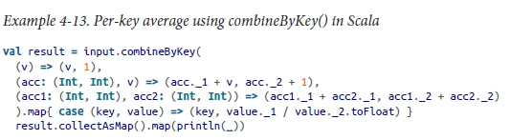

**Union Function**

**Note :** does not remove duplicates, just appends file when applied on files or appends collection when applied on collections

**Union on RDD for files:**

val rdd1 = sc.textFile("hdfs://hdpnn.capgemini.com:8020/user/viagrawa/www.txt")

val rdd2 = sc.textFile("hdfs://hdpnn.capgemini.com:8020/user/viagrawa/santosh.txt")

val newrdd = rdd1.union(rdd2)

newrdd.collect()

**www.txt**

Rohan 24 HR 24567

Sonu 35 IT 35345

Santosh 23 ID 345356

Monu 67 HR 678659

**santosh.txt**

Santosh 23 ID 345356

Monu 67 HR 678659

**Output :**

res1: Array[String] = Array(Rohan 24 HR 24567, Sonu 35 IT 35345, Santosh 23 ID 345356, Monu 67 HR 678659, Santosh 23 ID 345356, Monu 67 HR 678659)

**Union on RDD for list/collection:**

val rdd1 = sc.parallelize(Seq((1, "Aug", 30),(1, "Sep", 31),(2, "Aug", 15),(2, "Sep", 10)))

val rdd2 = sc.parallelize(Seq((1, "Oct", 10),(1, "Nov", 12),(2, "Oct", 5),(1, "Nov", 12)))

val newrdd = rdd1.union(rdd2)

newrdd.collect()

**Output**

res0: Array[(Int, String, Int)] = Array((1,Aug,30), (1,Sep,31), (2,Aug,15), (2,Sep,10), (1,Oct,10), (1,Nov,12), (2,Oct,5), (1,Nov,12))

**Examples of RDD Functions :**

val rdd = sc.parallelize(List(1,2,3,4,5,4,3,2))

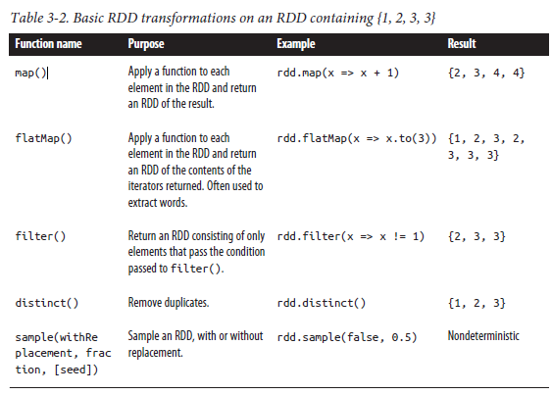

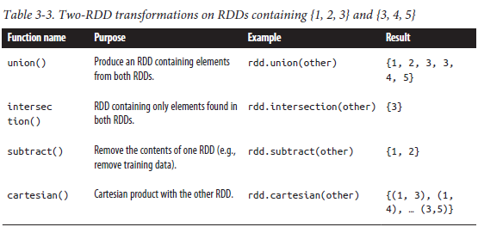

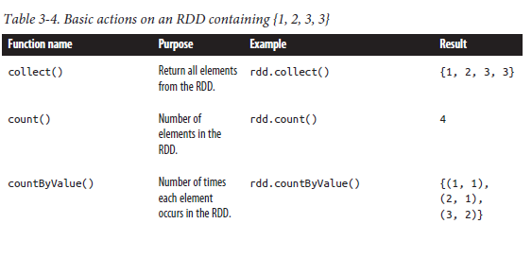

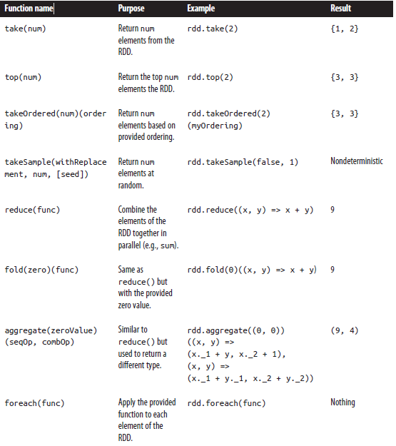

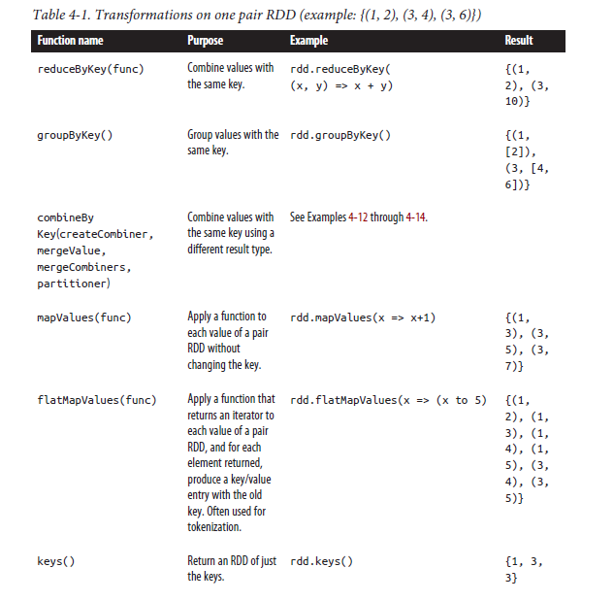

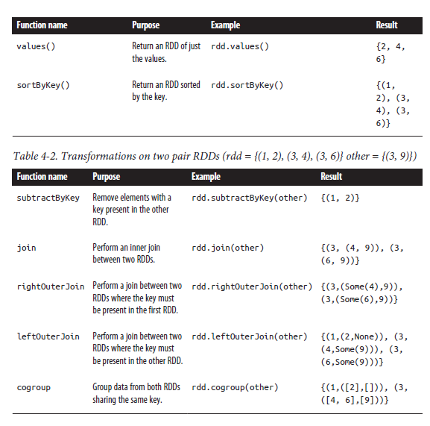

*Example 4-8. Per-key average with reduceByKey() and mapValues() in Scala*

**Mapvalues : when working with Key values**

val rdd = sc.parallelize(List(("panda",0),("pink",3),("pirate",3),("panda",1),("pink",1)))

**rdd.mapValues(x => (x, 1)).reduceByKey((x, y) => (x._1 + y._1, x._2 + y._2))**

Note: MapValues will map every value of Key Value pair with 1 ie ((‘panda’,(0,1), ((‘pink’,(3,1)), ((‘pirate’,(3,1)), ((‘panda’,(1,1)), ((‘pink’,(1,1)))

In ReduceByKey, the parameters is (x,y) here (x,y) are values ie first and second value ie (0,1) and (3,2).., x._1 is o and y._1 is 3 and x.2 is 1 and y.2 is 2.

**res3: Array[(String, (Int, Int))] = Array((pirate,(3,1)), (panda,(1,2)), (pink,(4,2))**

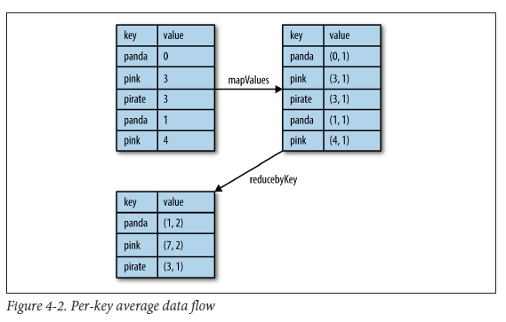

**Example 2**

**val rdd = sc.parallelize(List(("panda",0),("pink",3),("pirate",3),("panda",1),("pink",1)))**

rdd.reduceByKey((x, y) => (x+y)).collect()

res4: Array[(String, Int)] = Array((pirate,3), (panda,1), (pink,4))

**Using Aggregate :**

val rdd = sc.parallelize(List(1,2,3,4,5,4,3,2))

val result = rdd1.aggregate((0, 0))((acc, value) => (acc._1 + value, acc._2 + 1),(acc1, acc2) => (acc1._1 + acc2._1,acc1._2 + acc2._2))

**result: (Int, Int) = (15,5) ----(sum,count)**

(acc, value) – acc is accumulator which is assigned to zero, value is value (1,2,3,4,5…)

(acc._1 + value, acc._2 + 1), - accumulating values ie adding values at node level, incrementing counter at node level

(acc1, acc2) => (acc1._1 + acc2._1,acc1._2 + acc2._2) - accumulating values ie adding values from different nodes, adding counter from different node

**Using aggregateByKey : same as above, but works for Key value pair**

**Displaying the Lineage**

To display the lineage of an RDD, Spark provides a **toDebugString()** method. In

Example 8-8, we’ll look at some of the RDDs we created in the preceding example.

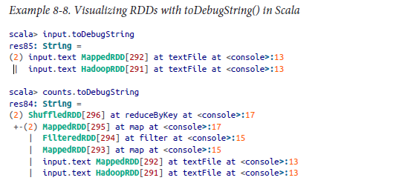

**val rdd = sc.textFile("/user/sanvekar/Salary_Data.txt")**

**val newRDD = rdd.flatMap(x=>List(x,1)).map(x=>(x,1111))**

**newRDD.toDebugString**

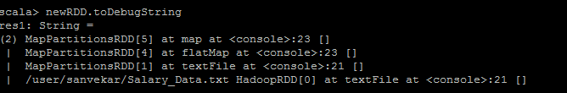

**Finding Information**

**Spark Web UI**

The first stop for learning about the behavior and performance of a Spark application

is Spark’s built-in web UI. This is available on the machine where the driver is running

at port 4040 by default

in the case of the YARN cluster mode,

where the application driver runs inside the cluster, you should access the UI through

the YARN ResourceManage

**Jobs: Progress and metrics of stages, tasks, and more**

The jobs page, shown in Figure 8-2, contains detailed execution information for

active and recently completed Spark jobs. One very useful piece of information on

this page is the progress of running jobs, stages, and tasks. Within each stage, this

page provides several metrics that you can use to better understand physical

execution.



*The Spark application UI’s jobs index page*

A common use for this page is to assess the performance of a job. A good first step is

to look through the stages that make up a job and see whether some are particularly

slow or vary significantly in response time across multiple runs of the same job.

you have an especially expensive stage, you can click through and better understand

what user code the stage is associated with.

**the stage page**

Once you’ve narrowed down a stage of interest, **the stage page**, shown in Figure 8-3,

can help isolate performance issues. In data-parallel systems such as Spark, a common

source of performance issues is *skew*, which occurs when a small number of

tasks take a very large amount of time compared to others. The stage page can help

you identify skew by looking at the distribution of different metrics over all tasks. A

good starting point is the runtime of the task; do a few tasks take much more time

than others? If this is the case, you can dig deeper and see what is causing the tasks to

be slow. Do a small number of tasks read or write much more data than others? Are

tasks running on certain nodes very slow? These are useful first steps when you’re

debugging a job.



***The Spark application UI’s stage detail page***

In addition to looking at task skew, it can be helpful to identify how much time tasks

are spending in each of the phases of the task lifecycle: reading, computing, and writing.

If tasks spend very little time reading or writing data, but take a long time overall,

it might be the case that the user code itself is expensive (for an example of user code optimizations, see “Working on a Per-Partition Basis” on page 107). Some tasks may

spend almost all of their time reading data from an external storage system, and will

not benefit much from additional optimization in Spark since they are bottlenecked

on input read.

**Storage Page: Information for RDDs that are persisted**

The storage page contains information about persisted RDDs. An RDD is persisted if

someone called persist() on the RDD *and* it was later computed in some job. In

some cases, if many RDDs are cached, older ones will fall out of memory to make

space for newer ones. This page will tell you exactly what fraction of each RDD is

cached and the quantity of data cached in various storage media (disk, memory, etc.).

It can be helpful to scan this page and understand whether important datasets are fitting

into memory or not.

Note : Persist – could memory only or memory and disk or disk only, Cache – Memory only

**Executors: A list of executors present in the application**

This page lists the active executors in the application along with some metrics around

the processing and storage on each executor. One valuable use of this page is to confirm

that your application has the amount of resources you were expecting. A good

first step when debugging issues is to scan this page, since a misconfiguration resulting

in fewer executors than expected can, for obvious reasons, affect performance. It

can also be useful to look for executors with anomalous behaviors, such as a very

large ratio of failed to successful tasks. An executor with a high failure rate could

indicate a misconfiguration or failure on the physical host in question. Simply

removing that host from the cluster can improve performance.

Another feature in the executors page is the ability to collect a stack trace from executors using the Thread Dump button (this feature was introduced in Spark 1.2). Visualizing the thread call stack of an executor can show exactly what code is executing at an instant in time

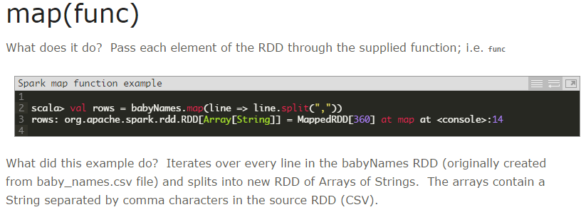

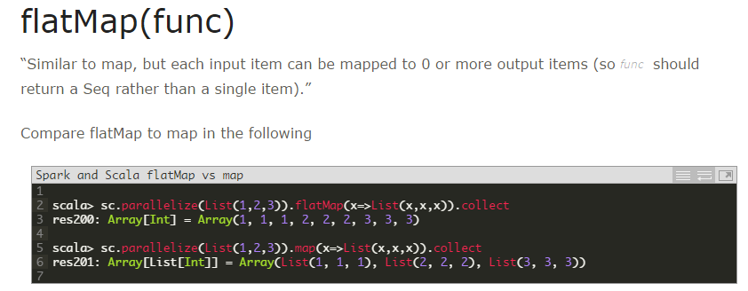

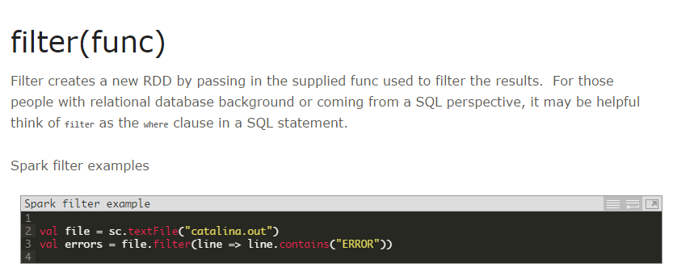

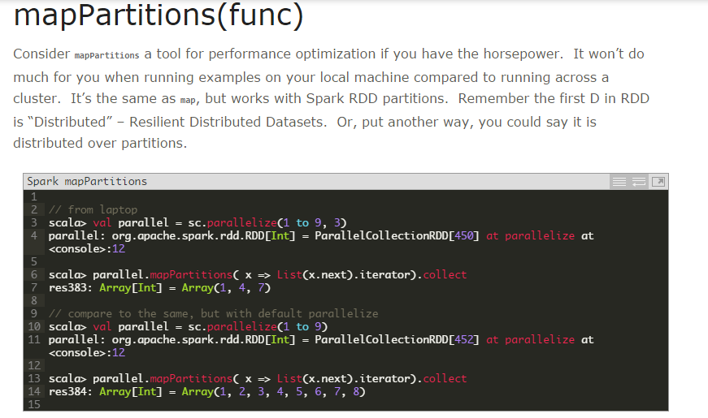

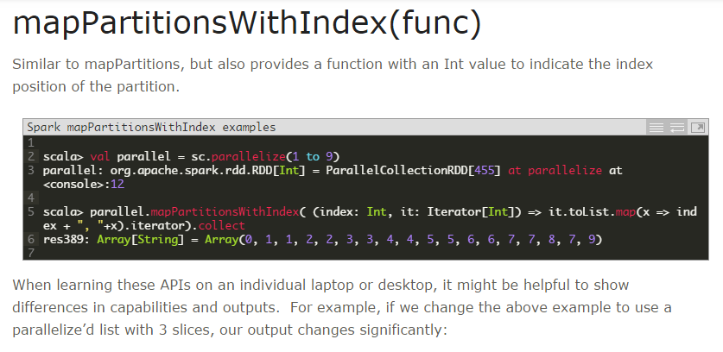

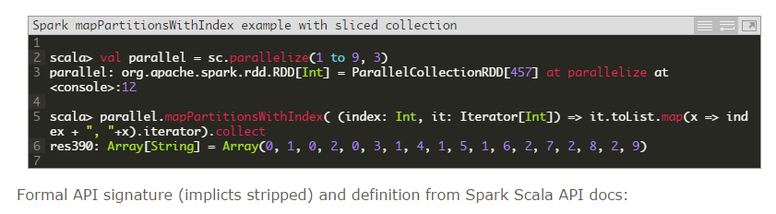

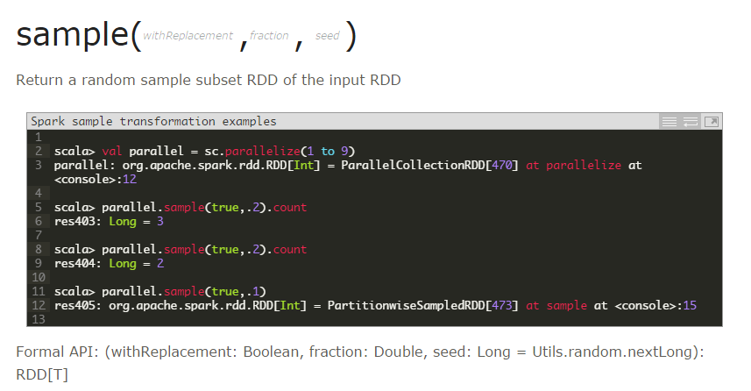

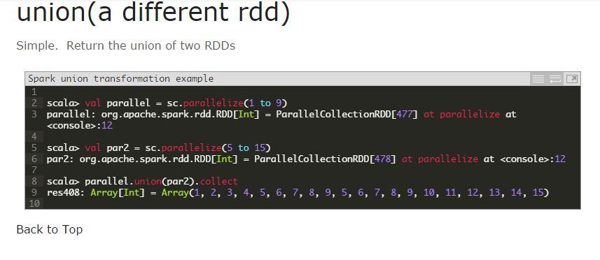

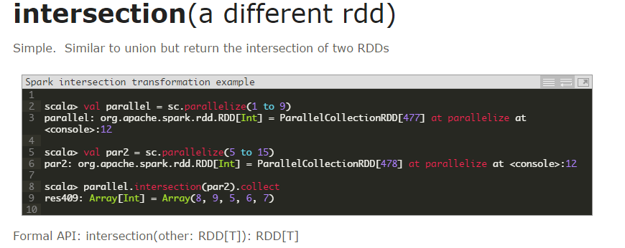

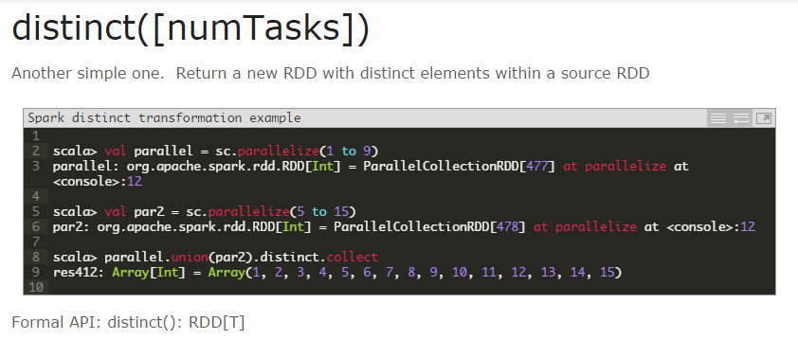



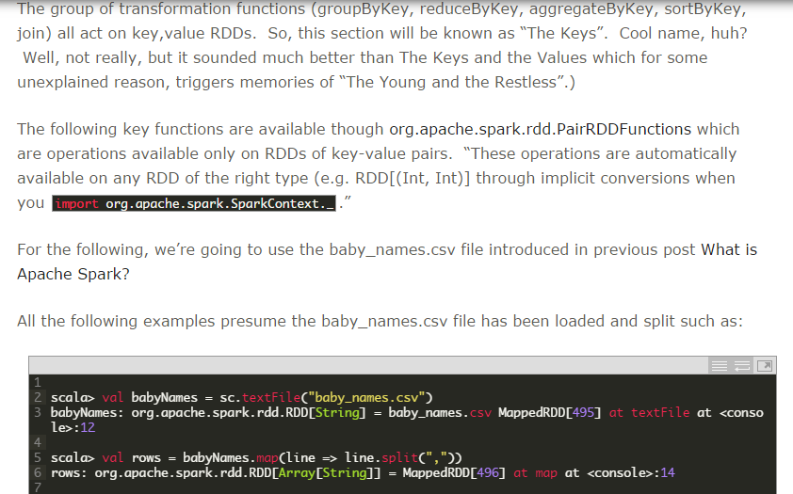

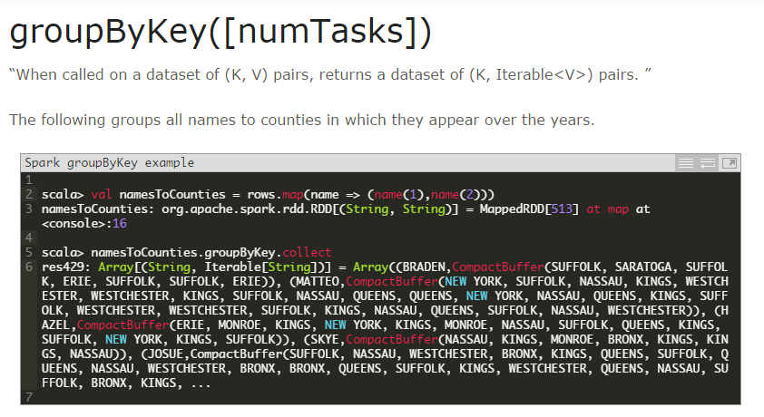

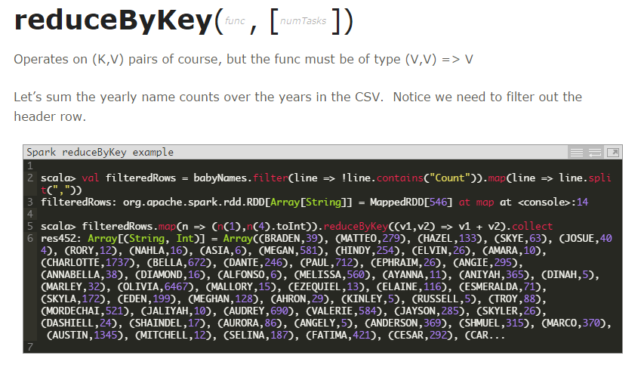

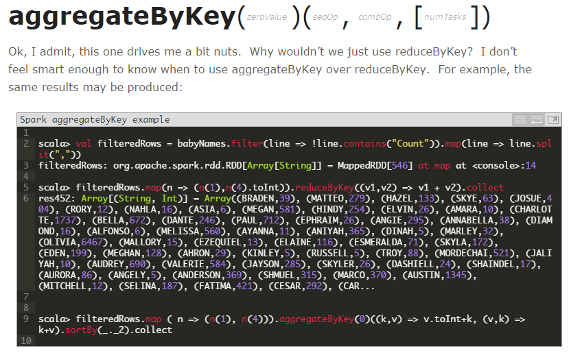

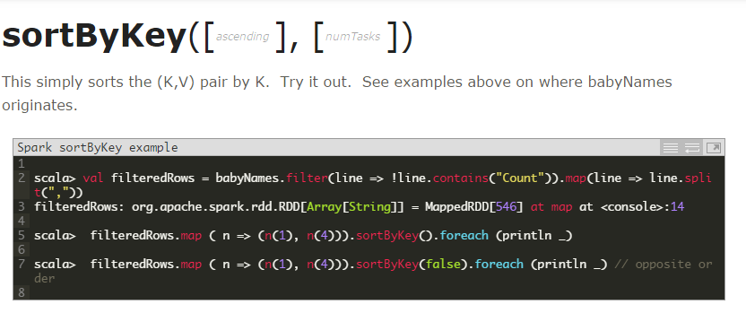

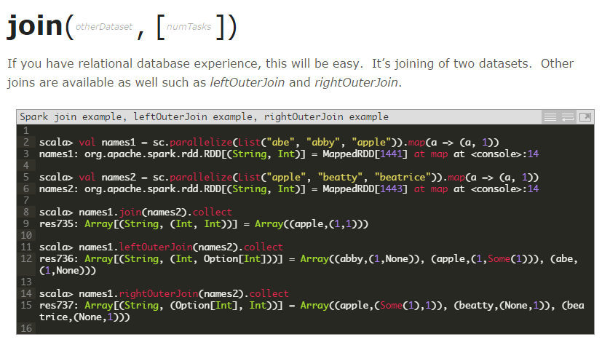

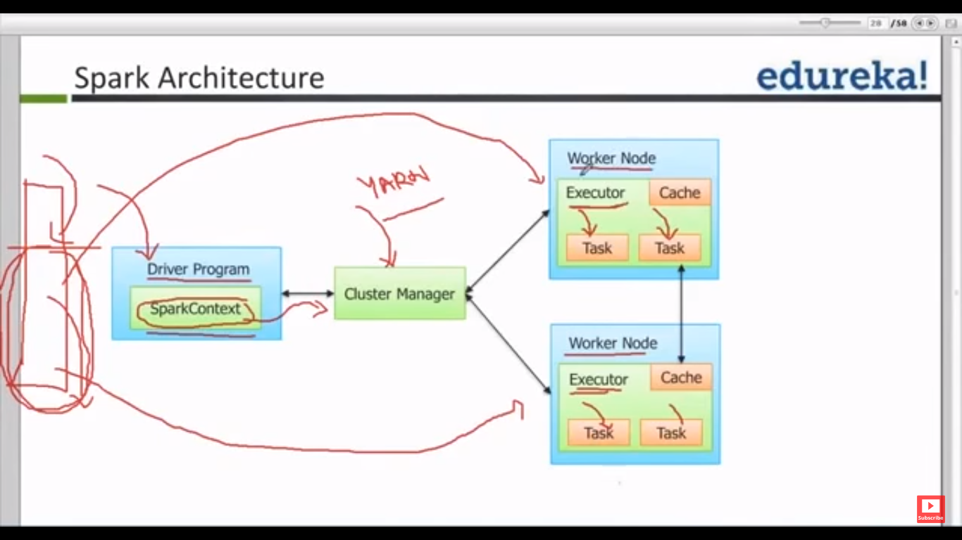

**Executors – Are nothing but JVM on memory**

**Driver Program : Our spark program which we write which has spark conf ad spark context**

**Spark Runtime Architecture**

In distributed mode, Spark uses a master/slave architecture with one central coordinator and many distributed workers. The central coordinator is called the driver. The driver communicates with a potentially large number of distributed workers called executors. The driver runs in its own Java process and each executor is a separate Java process. A driver and its executors are together termed a Spark application.

Figure 7-1. The components of a distributed Spark application



A Spark application is launched on a set of machines using an external service called a cluster manager. As noted, Spark is packaged with a built-in cluster manager called the Standalone cluster manager. Spark also works with Hadoop YARN and Apache Mesos, two popular open source cluster managers.

The Driver

The driver is the process where the main() method of your program runs. It is the

process running the user code that creates a SparkContext, creates RDDs, and performs

transformations and actions. When you launch a Spark shell, you’ve created a

driver program (if you remember, the Spark shell comes preloaded with a SparkContext

called sc). Once the driver terminates, the application is finished.

When the driver runs, it performs two duties:

*Converting a user program into tasks*

The Spark driver is responsible for converting a user program into units of physical

execution called *tasks*. At a high level, all Spark programs follow the same structure: they create RDDs from some input, derive new RDDs from those using transformations, and perform actions to collect or save data. A Spark program implicitly creates a logical *directed acyclic graph* (DAG) of operations. When the driver runs, it converts this logical graph into a physical execution

Spark performs several optimizations, such as “pipelining” map transformations

together to merge them, and converts the execution graph into a set of *stages*. Each stage, in turn, consists of multiple *tasks*. The tasks are bundled up and prepared

to be sent to the cluster. Tasks are the smallest unit of work in Spark; a typical user program can launch hundreds or thousands of individual tasks.

*Scheduling tasks on executors*

Given a physical execution plan, a Spark driver must coordinate the scheduling

of individual tasks on executors. When executors are started they register themselves

with the driver, so it has a complete view of the application’s executors at

all times. Each executor represents a process capable of running tasks and storing

RDD data.

The Spark driver will look at the current set of executors and try to schedule each

task in an appropriate location, based on data placement. When tasks execute,

they may have a side effect of storing cached data. The driver also tracks the location

of cached data and uses it to schedule future tasks that access that data.

Executors

Spark executors are worker processes responsible for running the individual tasks in

a given Spark job. Executors are launched once at the beginning of a Spark application

and typically run for the entire lifetime of an application, though Spark applications

can continue if executors fail. Executors have two roles. First, they run the tasks

that make up the application and return results to the driver. Second, they provide

in-memory storage for RDDs that are cached by user programs, through a service

called the Block Manager that lives within each executor. Because RDDs are cached

directly inside of executors, tasks can run alongside the cached data.

Cluster Manager

So far we’ve discussed drivers and executors in somewhat abstract terms. But how do

drivers and executor processes initially get launched? Spark depends on a cluster manager to launch executors and, in certain cases, to launch the driver. The cluster

manager is a pluggable component in Spark. This allows Spark to run on top of

different external managers, such as YARN and Mesos, as well as its built-in Standalone

cluster manager.

Launching a Program

No matter which cluster manager you use, Spark provides a single script you can use

to submit your program to it called spark-submit. Through various options, sparksubmit

can connect to different cluster managers and control how many resources

your application gets. For some cluster managers, spark-submit can run the driver

within the cluster (e.g., on a YARN worker node), while for others, it can run it only

on your local machine

**Summary**

To summarize the concepts in this section, let’s walk through the exact steps that occur when you run a Spark application on a cluster:

1. The user submits an application using spark-submit.

2. spark-submit launches the driver program and invokes the main() method

specified by the user.

3. The driver program contacts the cluster manager to ask for resources to launch

executors.

4. The cluster manager launches executors on behalf of the driver program.

5. The driver process runs through the user application. Based on the RDD actions and transformations in the program, the driver sends work to executors in the form of tasks.

6. Tasks are run on executor processes to compute and save results.

7. If the driver’s main() method exits or it calls SparkContext.stop(), it will terminate the executors and release resources from the cluster manager.

Lazy Evaluation

As you read earlier, transformations on RDDs are lazily evaluated, meaning that

Spark will not begin to execute until it sees an action. This can be somewhat counterintuitive

for new users, but may be familiar for those who have used functional languages

such as Haskell or LINQ-like data processing frameworks.

Lazy evaluation means that when we call a transformation on an RDD (for instance,

calling map()), the operation is not immediately performed. Instead, Spark internally

records metadata to indicate that this operation has been requested. Rather than

thinking of an RDD as containing specific data, it is best to think of each RDD as

consisting of instructions on how to compute the data that we build up through

transformations. Loading data into an RDD is lazily evaluated in the same way transformations

are. So, when we call sc.textFile(), the data is not loaded until it is necessary.

As with transformations, the operation (in this case, reading the data) can

occur multiple times.

Spark uses lazy evaluation to reduce the number of passes it has to take over our data

by grouping operations together. In systems like Hadoop MapReduce, developers

often have to spend a lot of time considering how to group together operations to

minimize the number of MapReduce passes. In Spark, there is no substantial benefit

to writing a single complex map instead of chaining together many simple operations.

Thus, users are free to organize their program into smaller, more manageable

operations.

Deploying Applications with spark-submit

Spark provides a single tool for submitting jobs across all cluster managers, called spark-submit.

**Map Function :**

**Example 1:**

val stringlist: List[String] = List("ab", "cde", "f")

val intlist: List[Int] = stringlist.map( x => x.length )

The map method expects a function. A function, that goes from String => Int. With that function, each element of the list is transformed. So the value of intlist is List( 2, 3, 1 )

Here, we have created an anonymous function from String => Int. That is x => x.length. One can even write the function more explicit as

stringlist.map( (x: String) => x.length )

f you do use write the above explicit, you can

val stringLength : (String => Int) = {

x => x.length

}

val intlist = stringlist.map( stringLength )

So, here it is absolutely evident, that stringLength is a function from String to Int.

Output : intlist will contain the length of each element of stringlist

intlist: List[Int] = List(2, 3, 1)

**Example 2:**

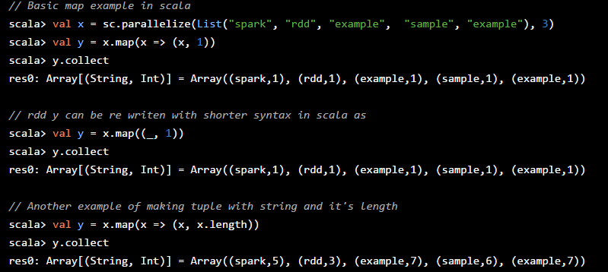

**Reduce Function:**

What does reduce. Example:

List( 1, 2, 3, 4 ).reduce( (x,y) => x + y )

Step 1 : op( 1, 2 ) will be the first evaluation.

Start with 1, 2, that is

x is 1 and y is 2

Step 2: op( op( 1, 2 ), 3 ) - take the next element 3

Take the next element 3:

x is op(1,2) = 3 and y = 3

Step 3: op( op( op( 1, 2 ), 3 ), 4)

Take the next element 4:

x is op(op(1,2), 3 ) = op( 3,3 ) = 6 and y is 4

Result here is the sum of the list elements, 10.

**SPARK SQL : Data Frames / Schema RDD**

**Difference between SchemaRDD of spark SQL and Data Frames.**

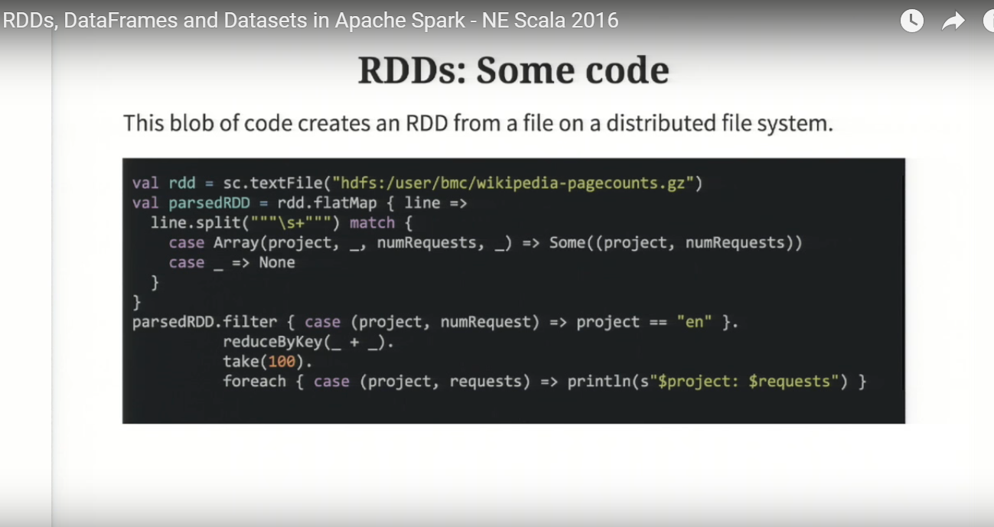

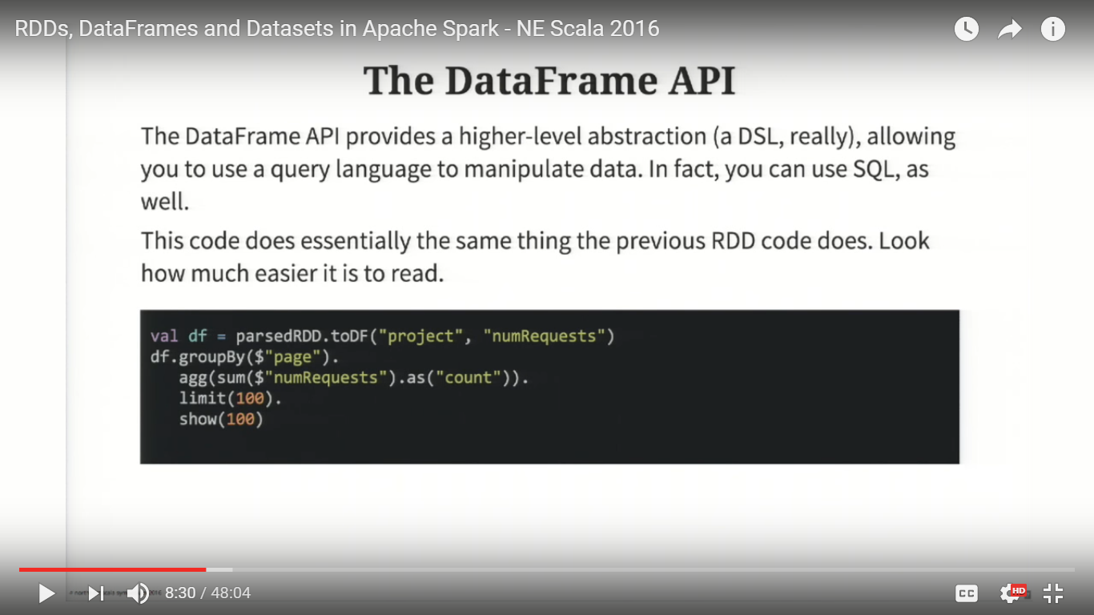

**Notes :**

In the above examples, the file is read using spark context sc.textfile, and then applied flat map to extract the required fields (ie columns or data), then created a dataframe using **toDF method** and passed the **column name (Schema)** (toDF(“project”, “numrequest”) as the argument and then applied SQL functions like groupby, aggr etc. But note, he has just used the SQL function but not applied the select queries like SQL.

To apply SELECT query like SQL, we will have to register the dataframe as a Temp table and then apply SQL SELECT and all other statistical func with select.

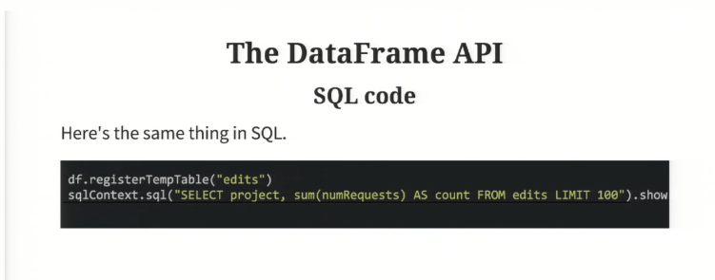

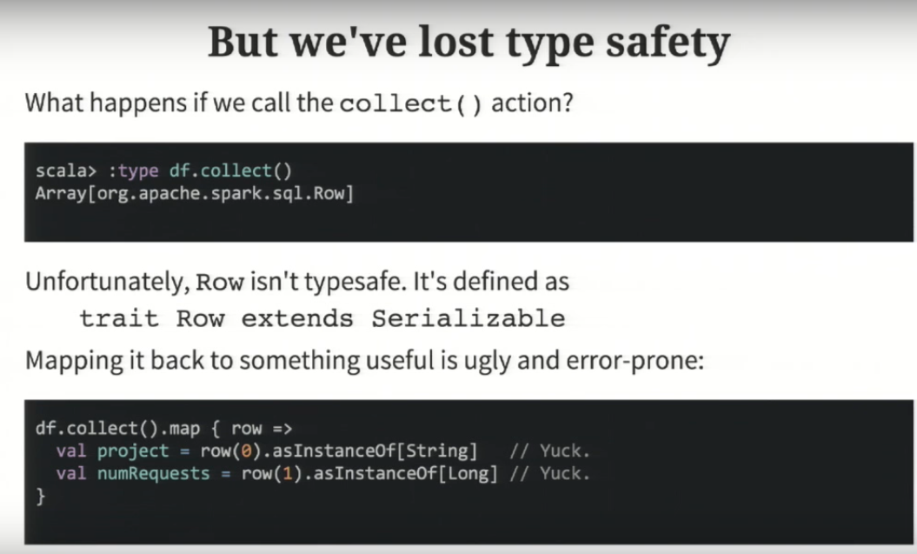

**DataSets**

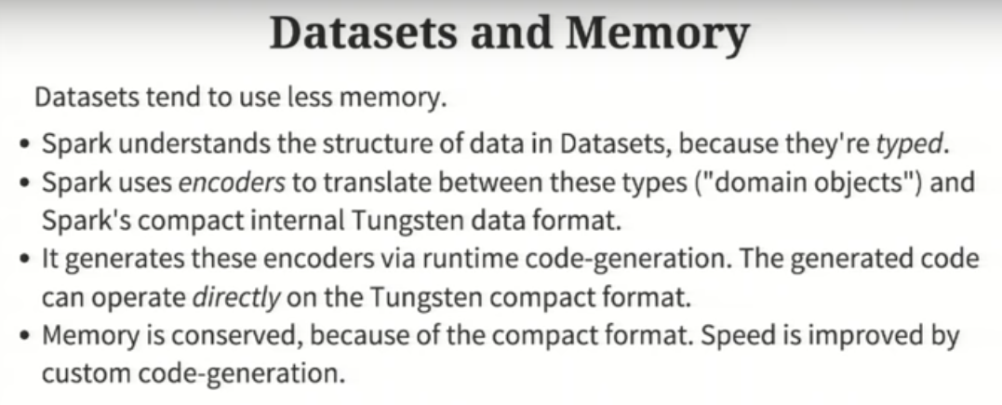

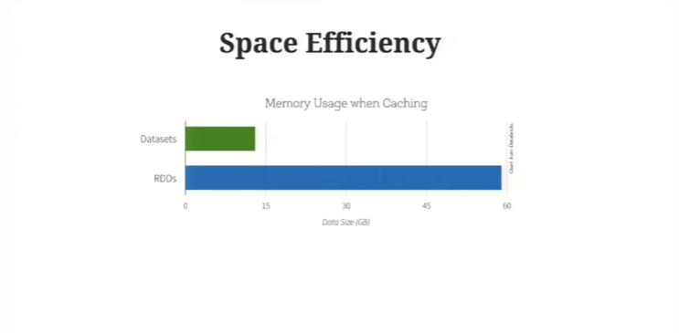

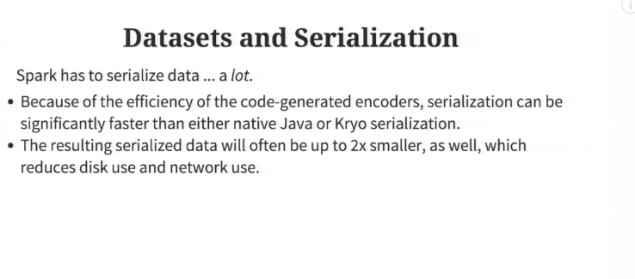

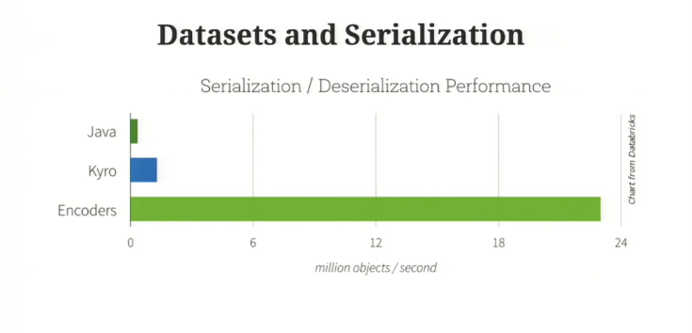

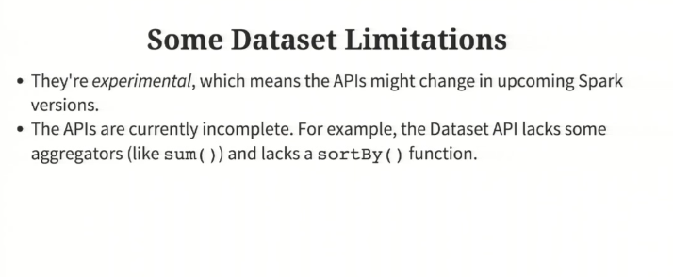

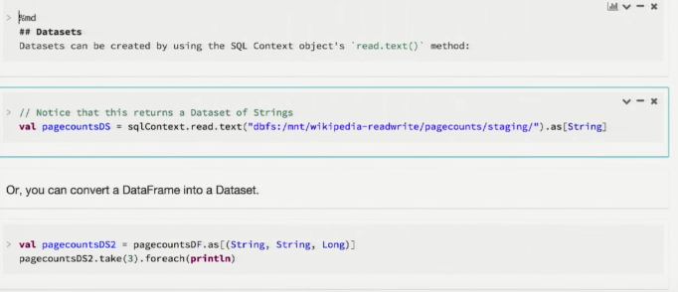

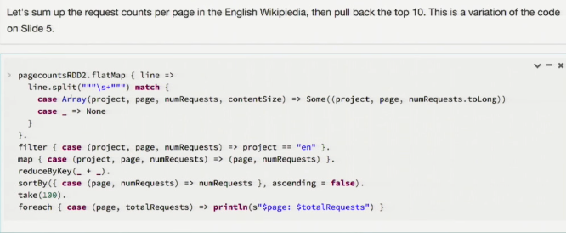

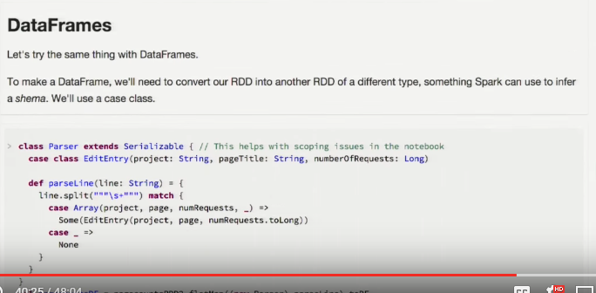

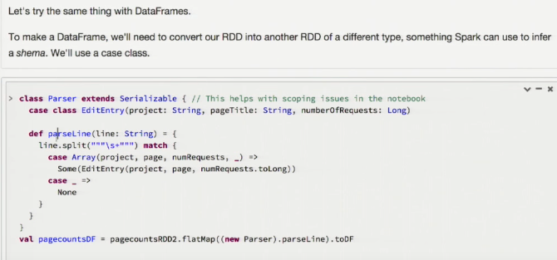

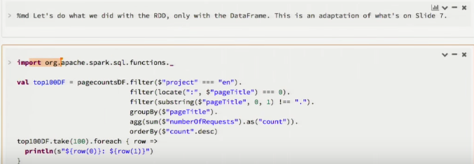

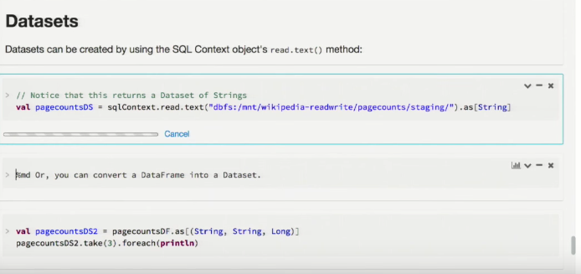

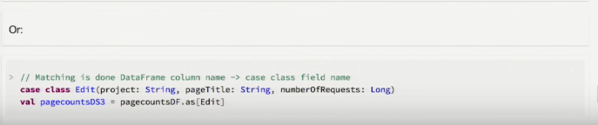

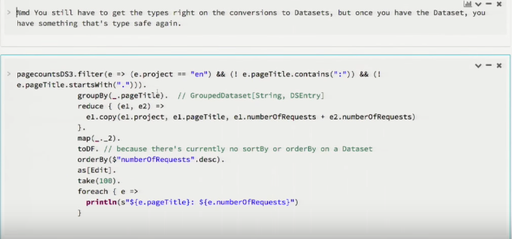

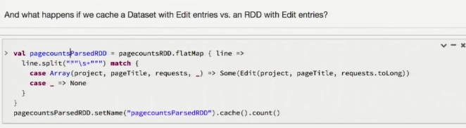

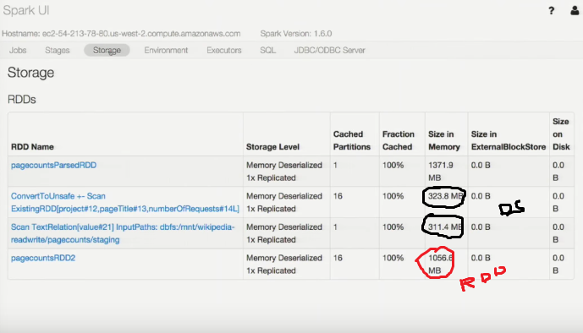

**????? : https://www.youtube.com/watch?v=pZQsDloGB4w&t=1673s**

**SchemaRDDs - Nothing but DataFrames**

Both loading data and executing queries return SchemaRDDs. SchemaRDDs are similar to tables in a traditional database. Under the hood, a SchemaRDD is an RDD composed of Row objects with additional schema information of the types in each column. Row objects are just wrappers around arrays of basic types (e.g., integers and strings), and we’ll cover them in more detail in the next section. One important note: in future versions of Spark, the name SchemaRDD may be changed to DataFrame.

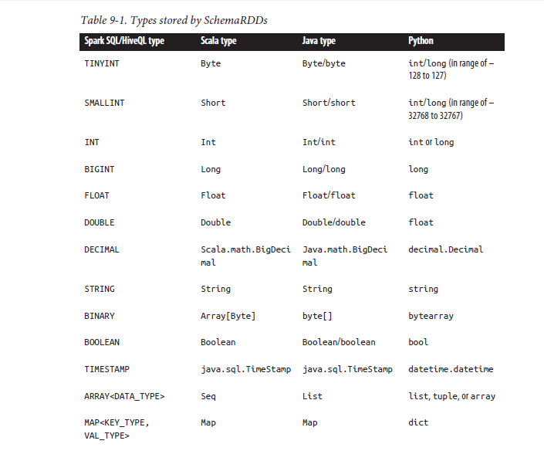

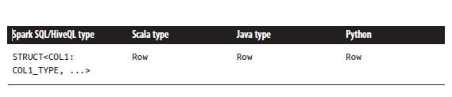

**Accessing/Creating Hive Table in Spark SQL using SchemaRDD**

**Accessing Hive table in Spark**

**import org.apache.spark.sql.hive.HiveContext**

**val** hiveCtx **= new HiveContext**(sc)

**val** rows **=** hiveCtx.sql("SELECT key, value FROM mytable")

**val** keys **=** rows.map(row **=>** row.getInt(0))

**Creating Hive table and Loading data in Spark**

val hiveContext = new org.apache.spark.sql.hive.HiveContext(sc)

hiveContext.sql("CREATE TABLE IF NOT EXISTS TestTable (key INT, value STRING)")

hiveContext.sql("LOAD DATA LOCAL INPATH 'examples/src/main/resources/kv1.txt' INTO TABLE TestTable")

hiveContext.sql("from TestTable SELECT key, collect_list(value) group by key order by key").collect.foreach(println)

**Accessing JSON file in Spark SQL using SchemaRDD**

**val** input **=** hiveCtx.jsonFile(inputFile)

*// Register the input schema RDD*

input.registerTempTable("tweets")

*// Select tweets based on the retweetCount*

**val** topTweets **=** hiveCtx.sql("SELECT text, retweetCount FROM

tweets ORDER BY retweetCount LIMIT 10")

Note : JSON format has field names in the data, so no schema is defined. Just register as temp table and aplly SQL Queries like select

**Accessing Parquet file in Spark SQL using SchemaRDD**

Parquet is a popular column-oriented storage format that can store records with nested

fields efficiently. It is often used with tools in the Hadoop ecosystem, and it supports all of the data types in Spark SQL. Spark SQL provides methods for reading

data directly to and from Parquet files.

*# Load some data in from a Parquet file with field's name and favouriteAnimal*

rows = hiveCtx.parquetFile(parquetFile)

names = rows.map(**lambda** row: row.name)

**print** "Everyone"

**print** names.collect()

tbl = rows.registerTempTable("people")

pandaFriends = hiveCtx.sql("SELECT name FROM people WHERE favouriteAnimal = **\"**panda**\"**")

**print** "Panda friends"

**print** pandaFriends.map(**lambda** row: row.name).collect()

**Creating Schema RDDs From other simple RDDs**

***Example 9-29. Creating a SchemaRDD from case class in Scala***

**case class HappyPerson**(handle**: String**, favouriteBeverage**: String**)

...

*// Create a person and turn it into a Schema RDD*

**val** happyPeopleRDD **=** sc.parallelize(**List**(**HappyPerson**("holden", "coffee")))

*// Note: there is an implicit conversion*

*// that is equivalent to sqlCtx.createSchemaRDD(happyPeopleRDD)*

happyPeopleRDD.registerTempTable("happy_people")

**Processing an CSV file in Spark SQL:**

Depending on your version of Scala, start the spark shell with a packages command line argument.

At time of this writing, scala 2.10 version:



**Spark 1.4+**

**Scala API**

import org.apache.spark.sql.SQLContext

val sqlContext = new SQLContext(sc)

val df = sqlContext.read

.format("com.databricks.spark.csv")

.option("header", "true") // Use first line of all files as header

.option("inferSchema", "true") // Automatically infer data types

.load("cars.csv")

val selectedData = df.select("year", "model")

selectedData.write

.format("com.databricks.spark.csv")

.option("header", "true")

.save("newcars.csv")

or

df. registerTempTable("Car")

Val Car_Data = sqlcontext.sql(“Select year, model from People”)

Car_data.collect.foreach(println)

**Note : you may also** register the dataframe df as temp table (df.registerTempTable("Car") and apply SQL statements using sqlcontext.sql(“Select year, model from People”)

**You can manually specify the schema when reading data:**

You can manually specify the schema when reading data:

import org.apache.spark.sql.SQLContext

import org.apache.spark.sql.types.{StructType, StructField, StringType, IntegerType}

val sqlContext = new SQLContext(sc)

**val customSchema = StructType(Array(**

**StructField("year", IntegerType, true),**

**StructField("make", StringType, true),**

**StructField("model", StringType, true),**

**StructField("comment", StringType, true),**

**StructField("blank", StringType, true)))**

val df = sqlContext.read

.format("com.databricks.spark.csv")

.option("header", "true") // Use first line of all files as header

.schema(customSchema)

.load("cars.csv")

val selectedData = df.select("year", "model")

selectedData.write

.format("com.databricks.spark.csv")

.option("header", "true")

.save("newcars.csv")

**Saving as compressed output**

val selectedData = df.select("year", "model")

selectedData.write

.format("com.databricks.spark.csv")

.option("header", "true")

.option("codec", "org.apache.hadoop.io.compress.GzipCodec")

.save("newcars.csv.gz")

**SPARK DataFrames**

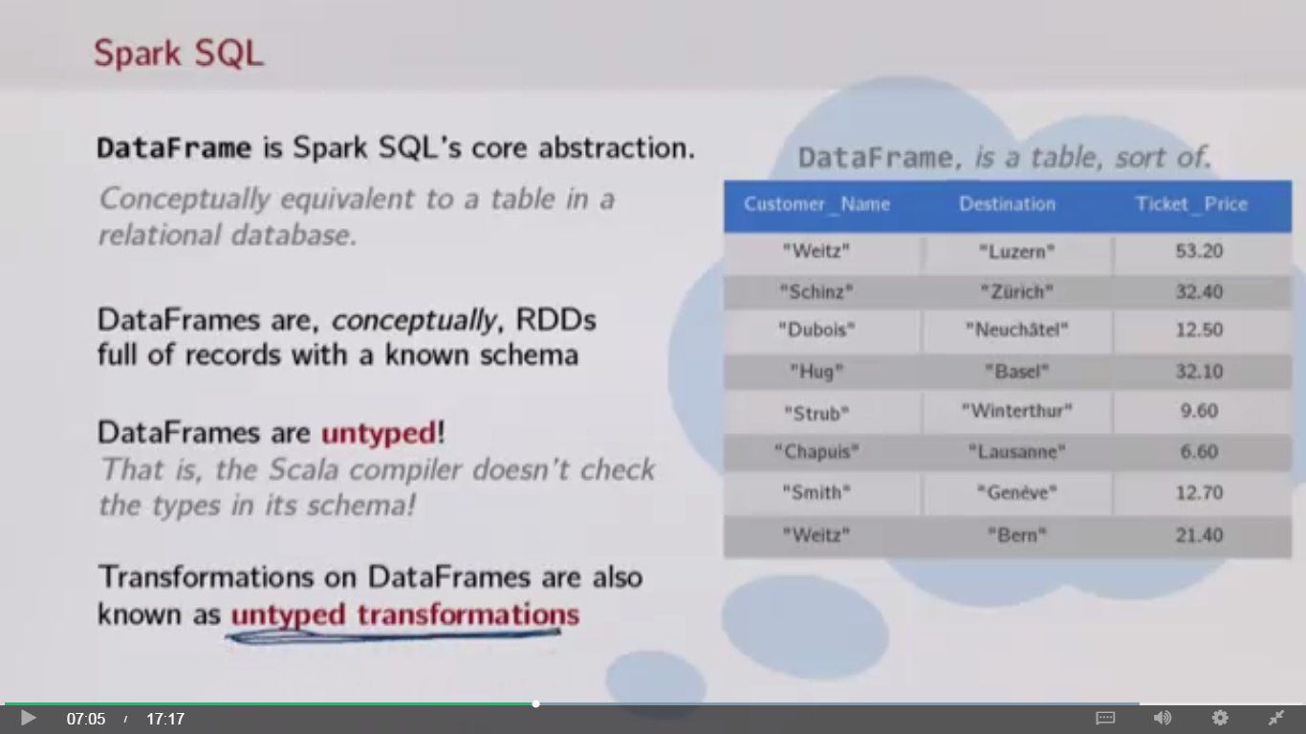

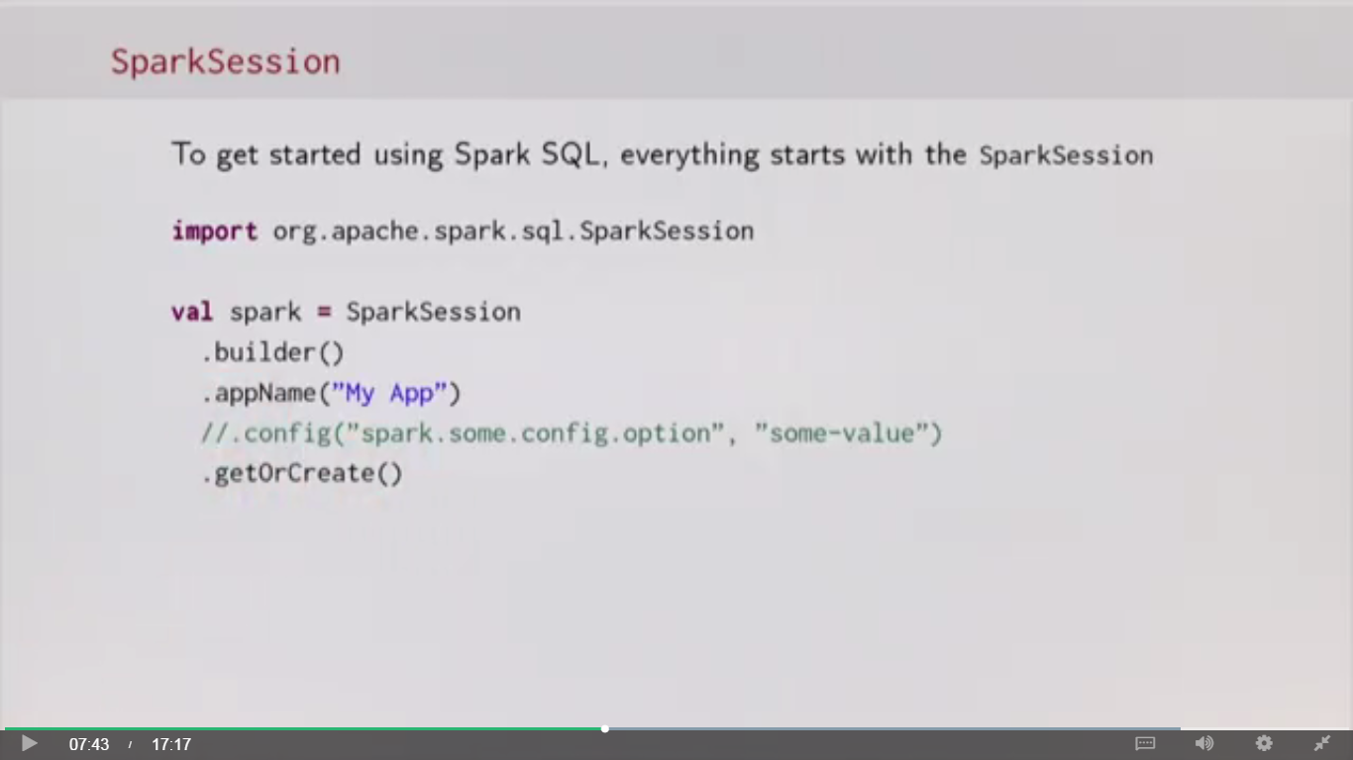

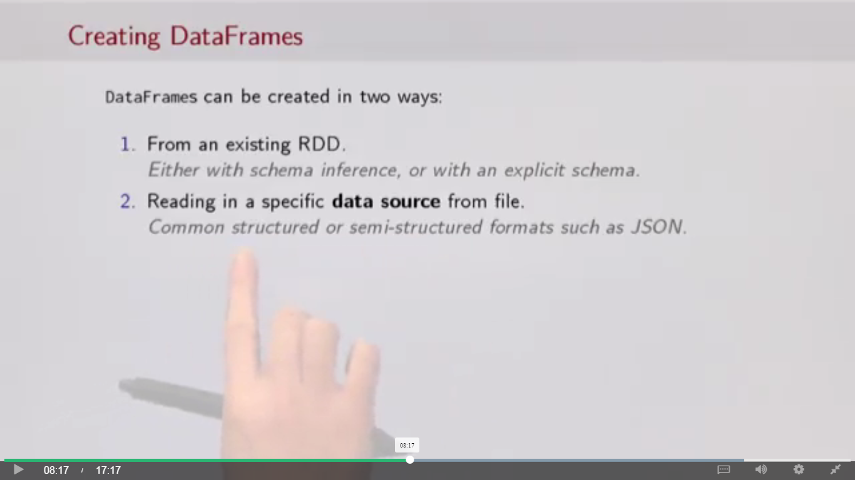

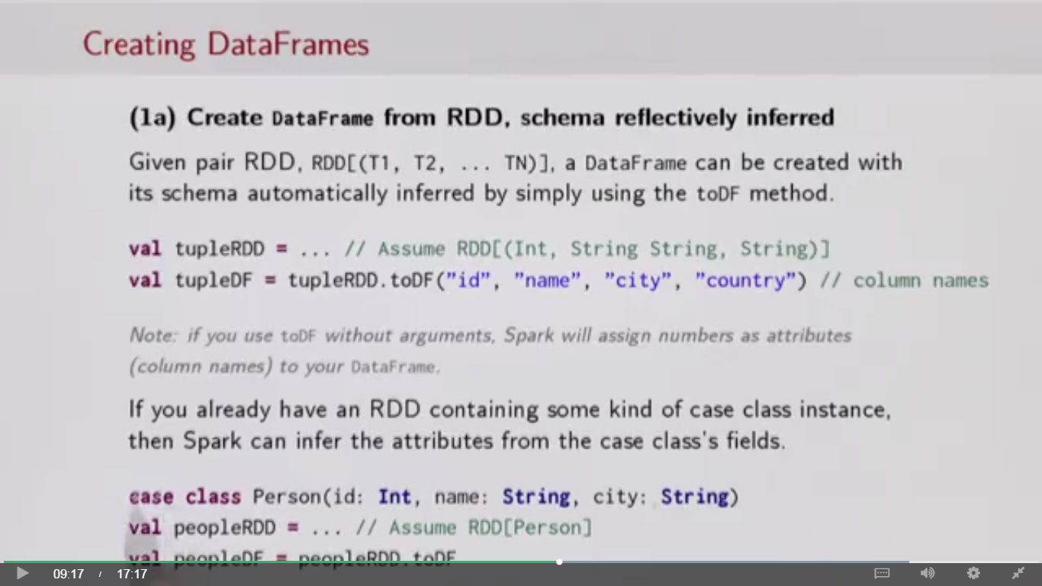

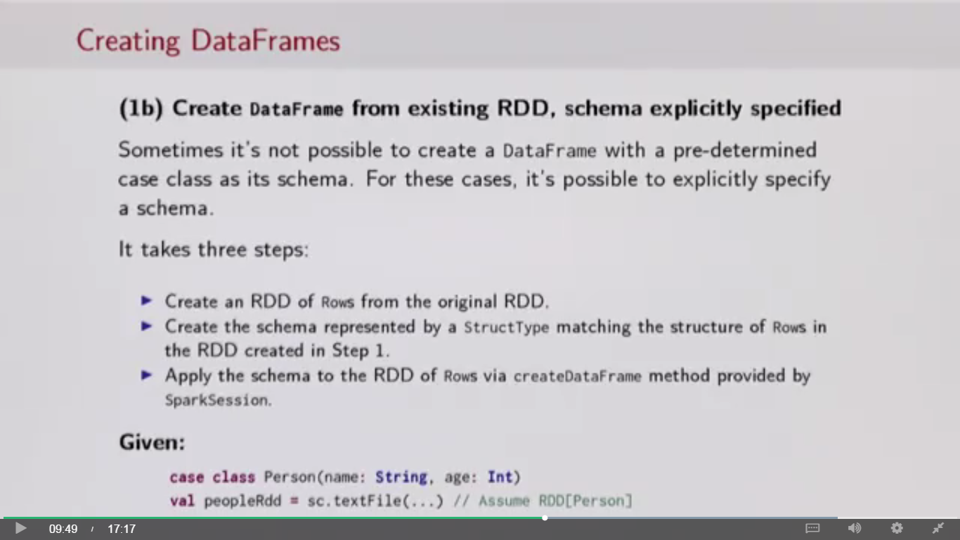

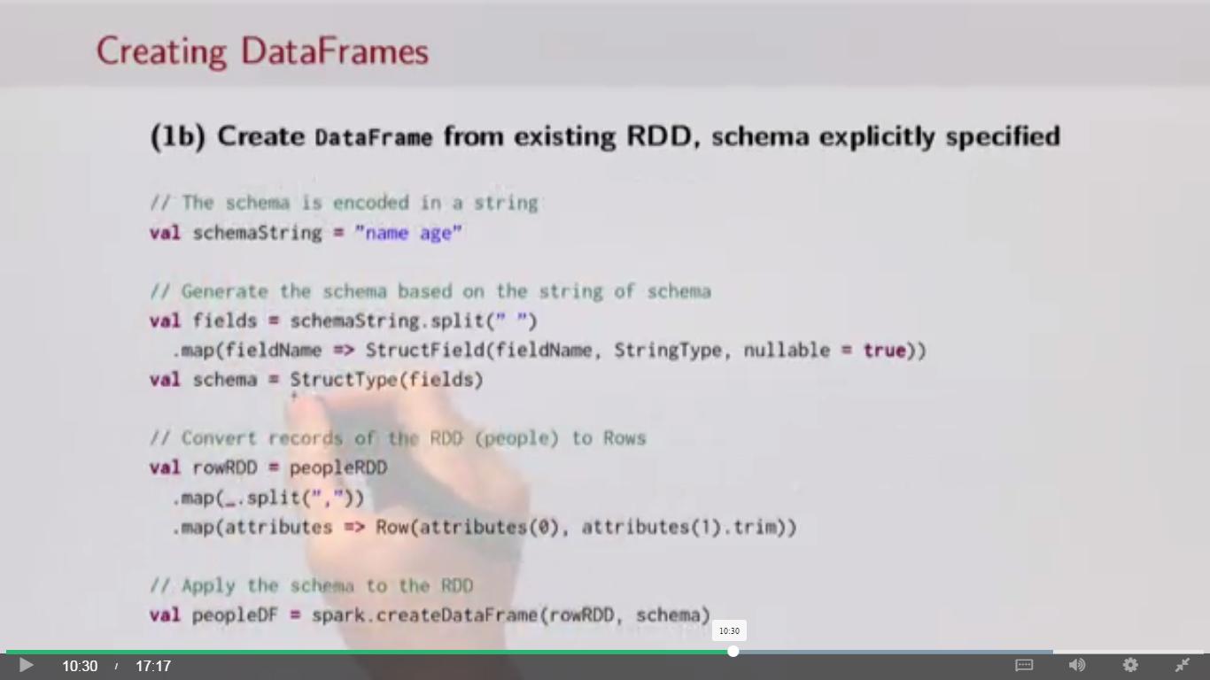

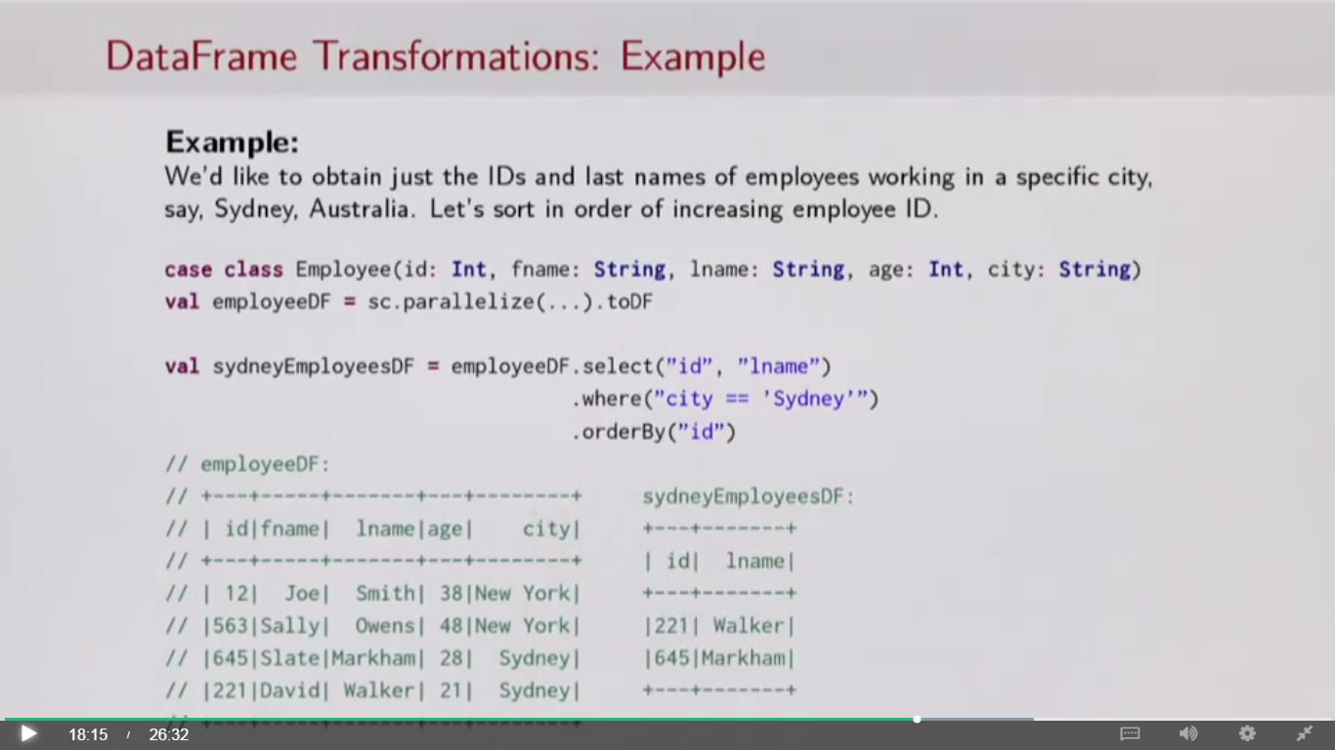

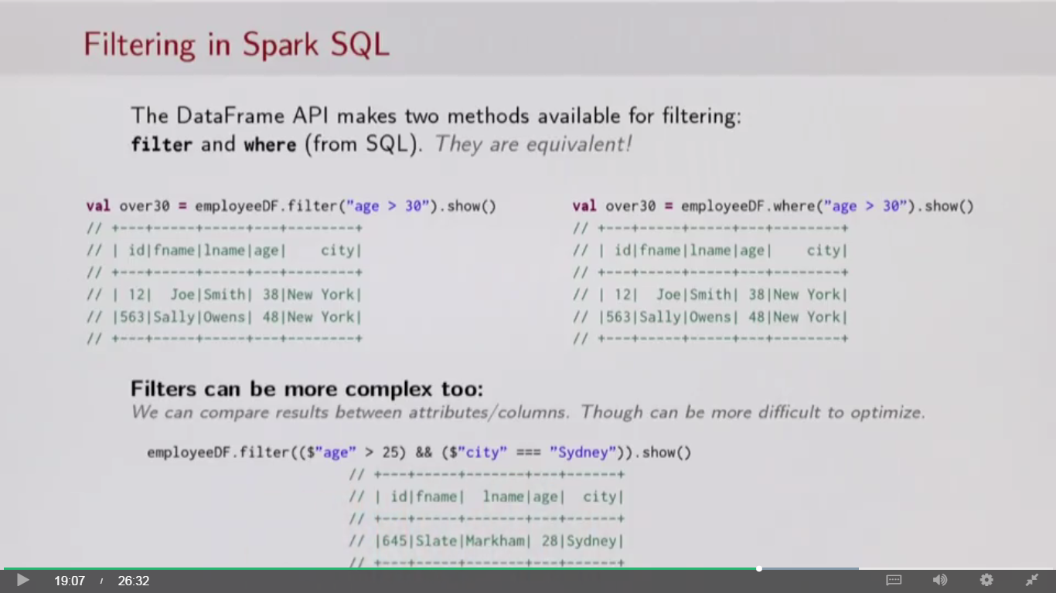

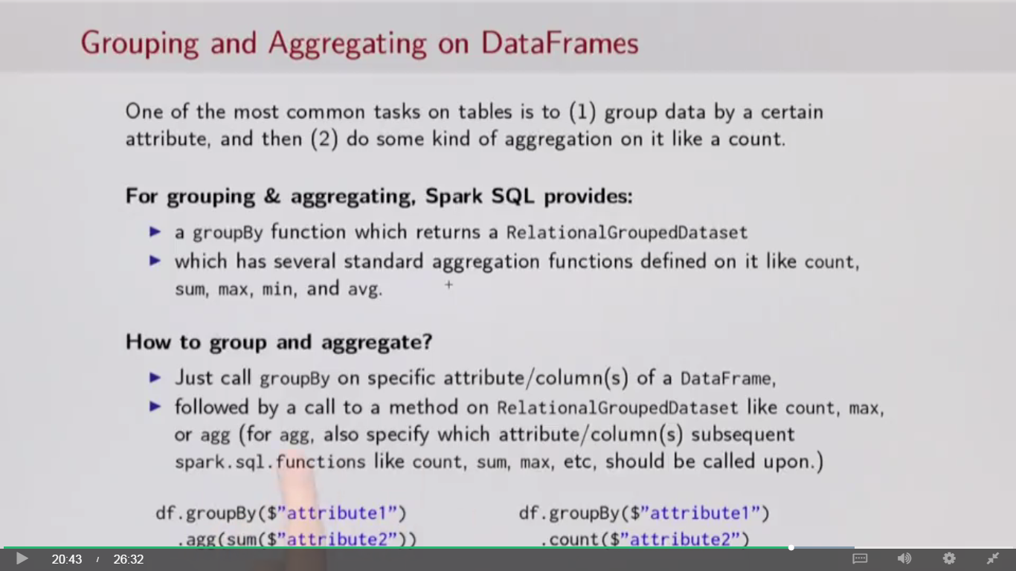

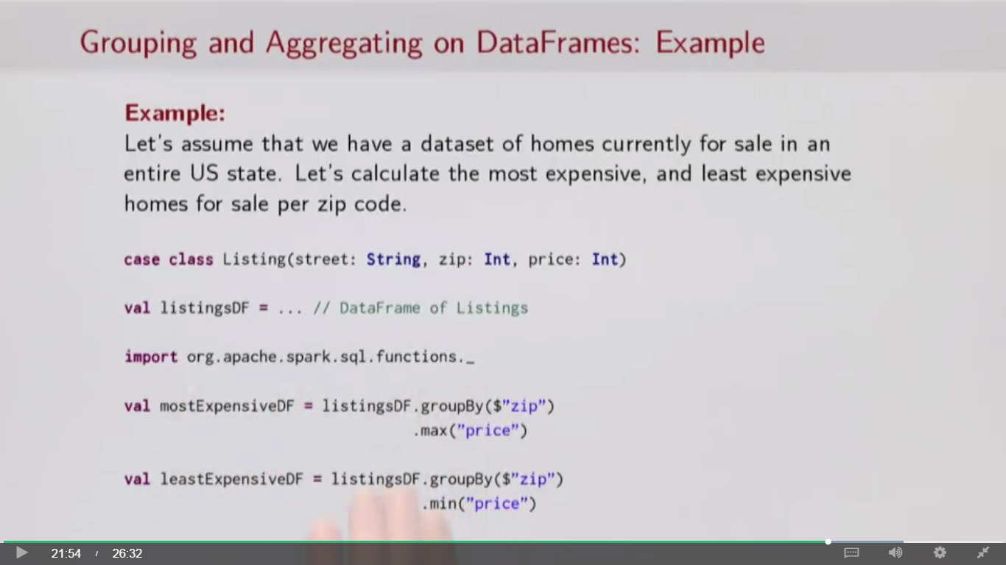

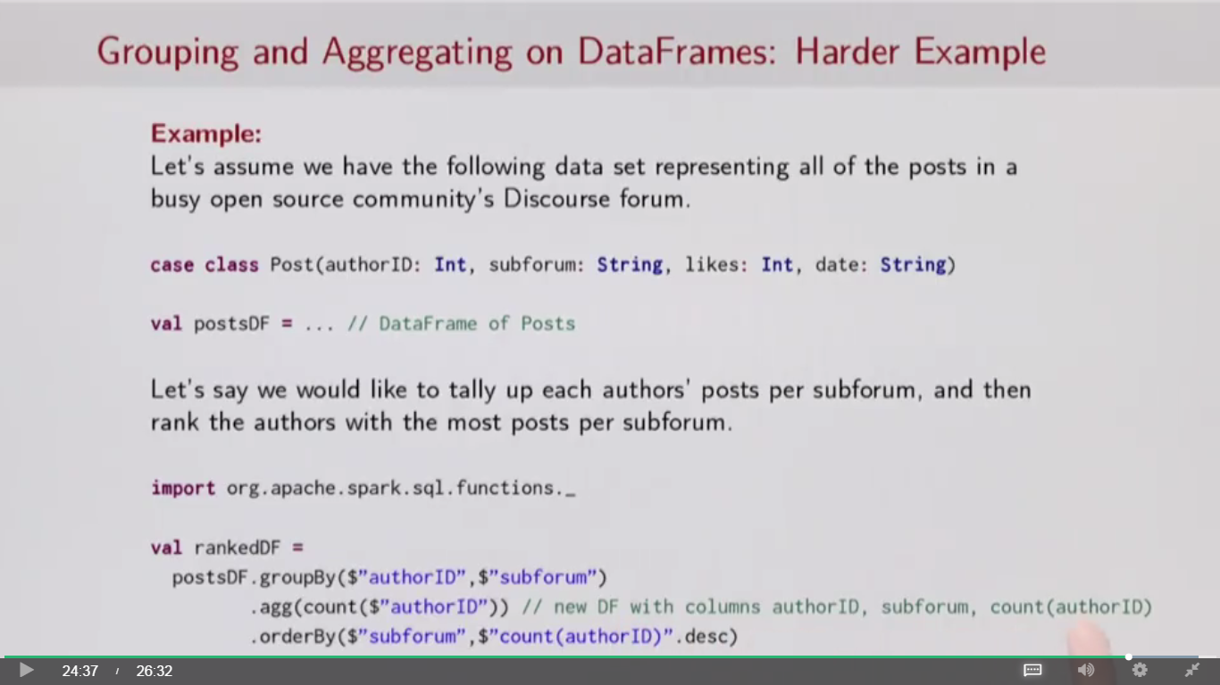

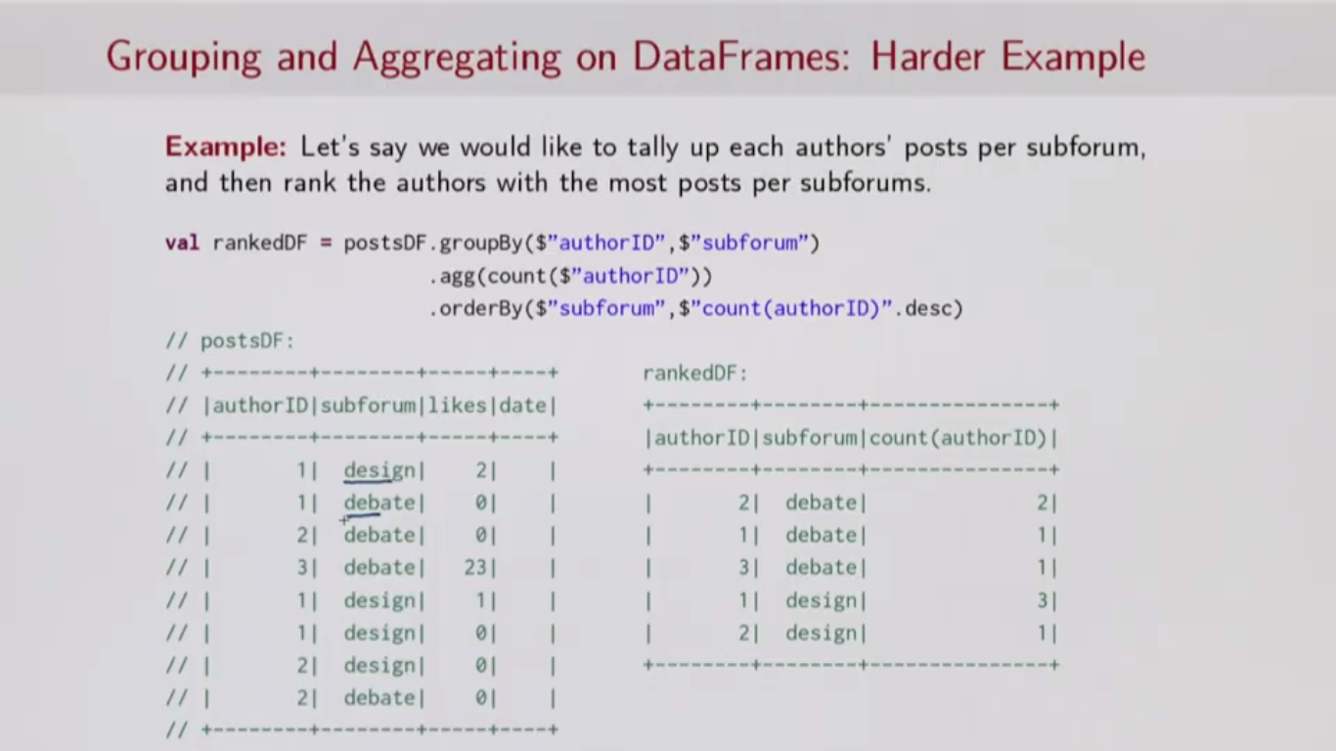

**Data Cleaning using Dataframes**

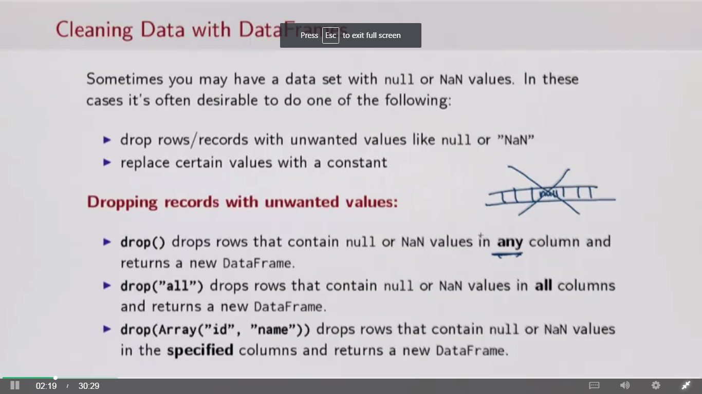

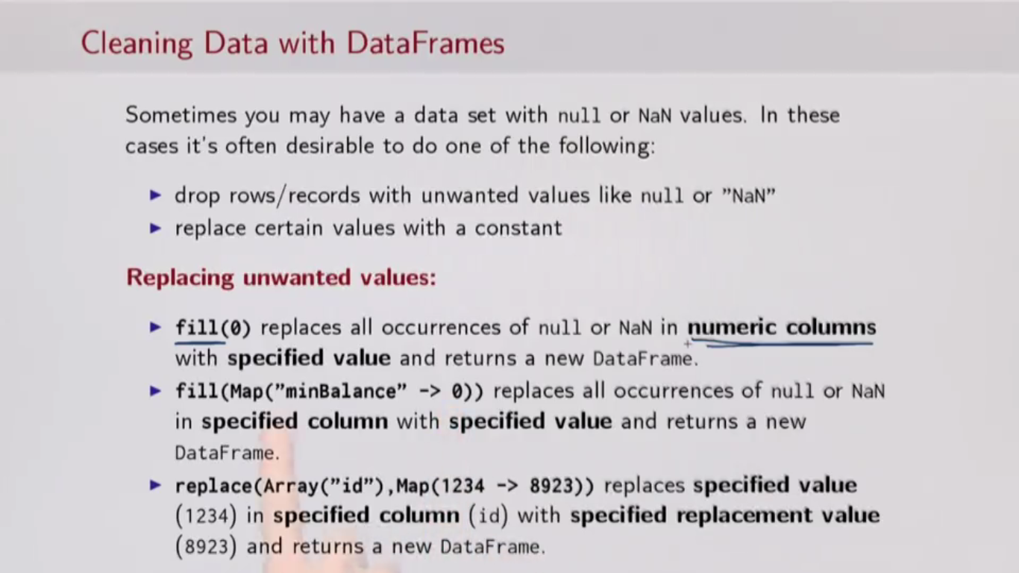

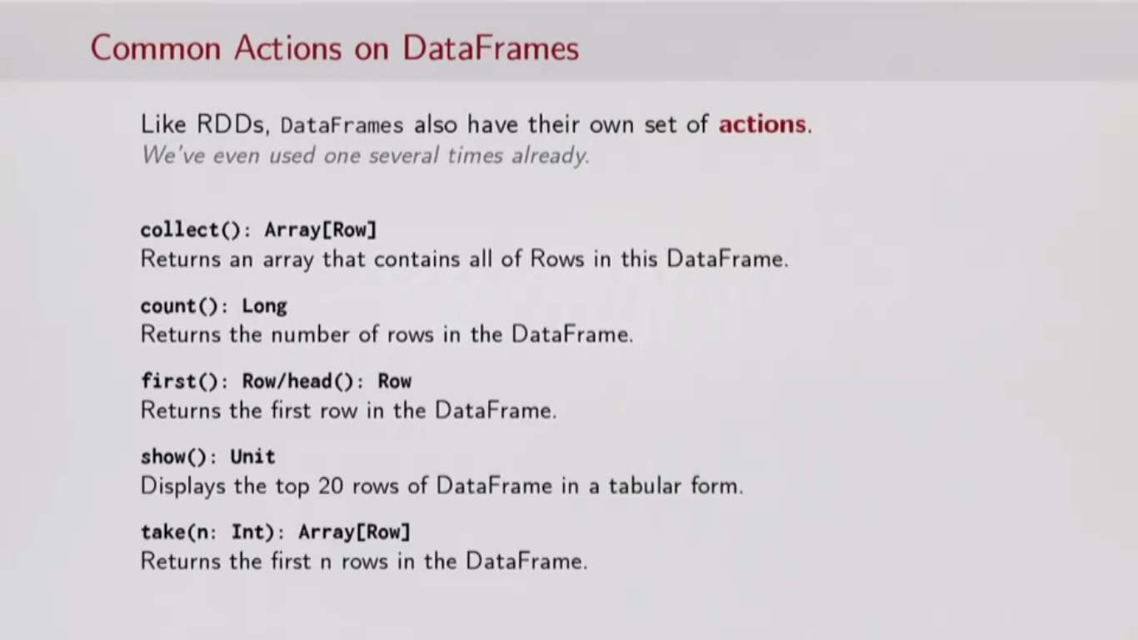

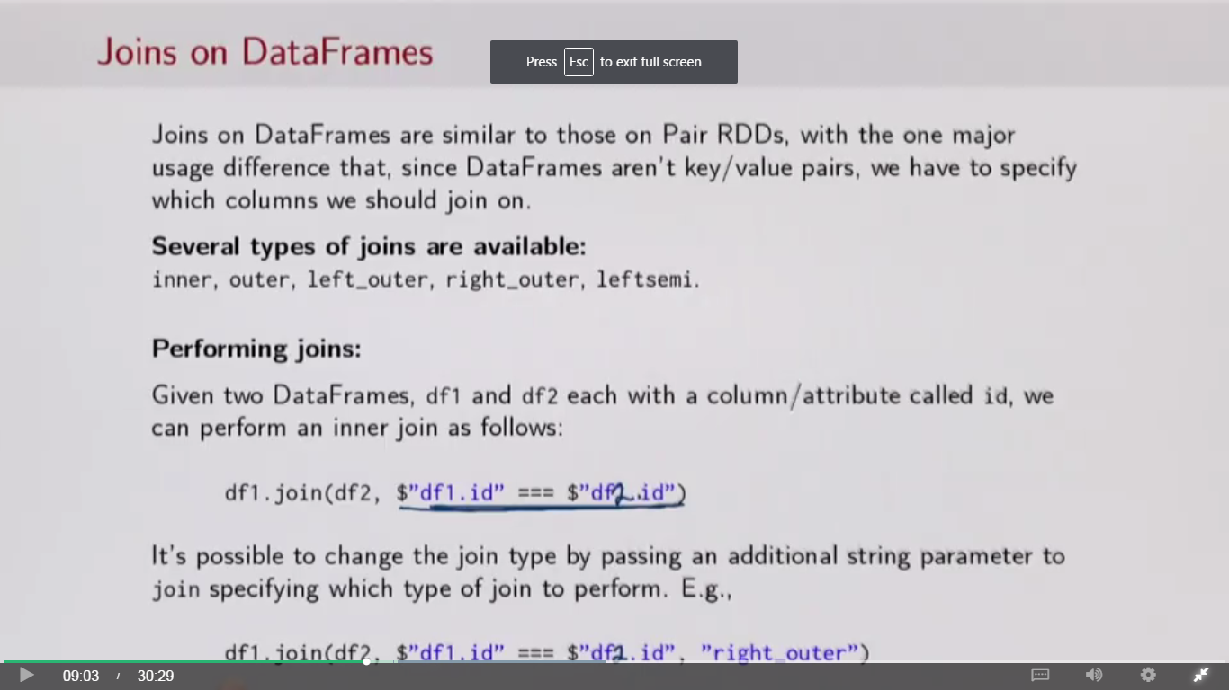

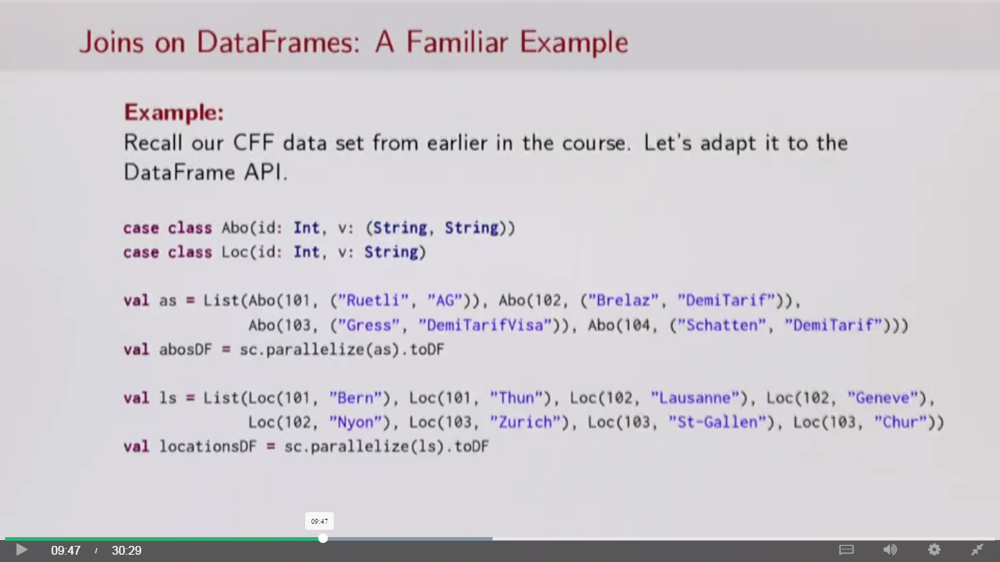

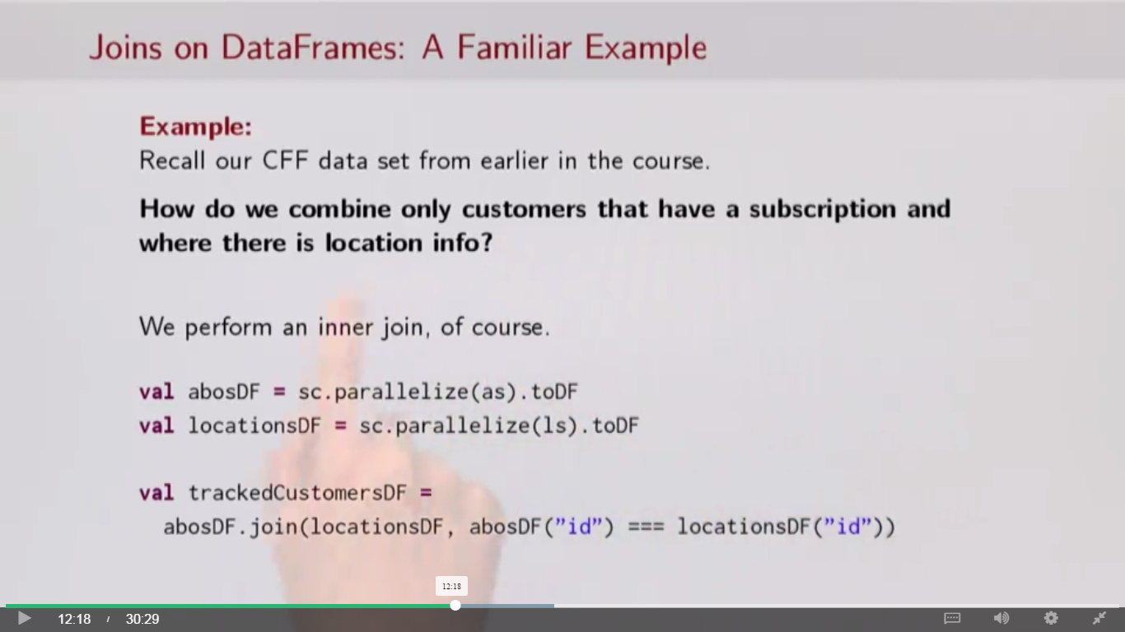

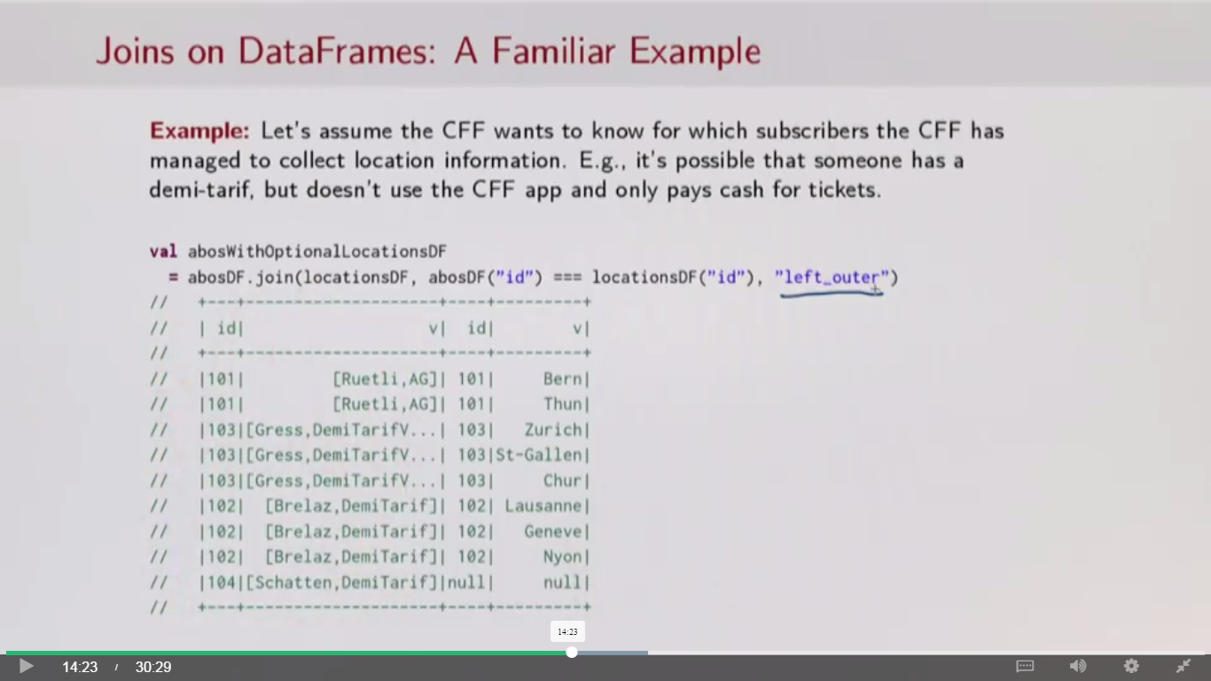

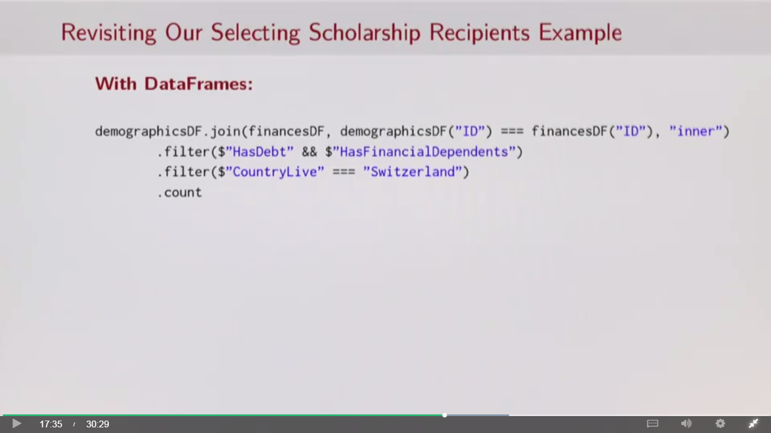

**Accessing tables from MySQL database and creating Dataframe in spark and save the data in Hive**

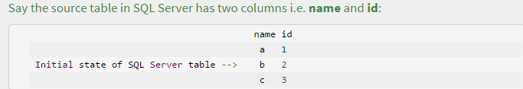

Establish a JDBC connection and create an initial data frame:

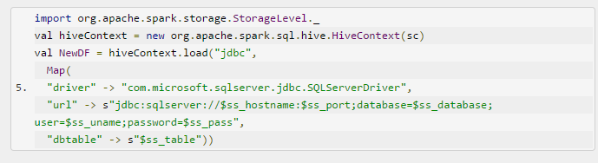

Save the dataframe (NewDF) as a hive table (hive_tbl):

NewDF.write.saveAsTable(“Hive_tbl”)

Note: Later we can use hivecontext.sql and query hive table in spark.

**Increment update of Hive table (imported from MySQL) from Spark:**

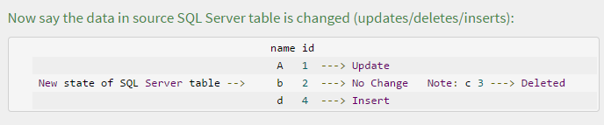

1. Create a Dataframe reading the hive table

val hiveContext = new org.apache.spark.sql.hive.HiveContext(sc)

Val OldDF = hiveContext.sql("SELECT * FROM hive_tbl")

OldDF.show()

+----+--+ |name|id| +----+--+ | a| 1| | b| 2| | c| 3| +----+--+

Segregate upserts (updates/inserts) by comparing the two data frames and save to **upserts_tbl**:

val upsertsDF = NewDF.except(OldDF) upsertsDF.write.saveAsTable("upserts_tbl")

UpsertsDF.show()

+----+--+ |name|id| +----+--+ | A| 1| ----> This DF has updated and inserted records only | d| 4| +----+--+

Similarly, segregate deletes by comparing the two data frames and save to **deletes_tbl**:

val deletesDF = OldDF.except(NewDF) deletesDF.write.saveAsTable("deletes_tbl")

deletesDF.show()

+----+--+ |name|id| +----+--+ | a| 1| ----> This DF has records to be deleted from hive_tbl | c| 3| +----+--+

Now, create a delete logic to remove all the records that match **deletes_tbl** from **hive_tbl**. *Note that this requires latest version of hive (0.14) and transactional table features enabled. Additionally bucketing and ORC storage formats should be applied on the table. I'm skipping these for ease*:

*e*:

1. %sql DELETE FROM hive_tbl
2. WHERE EXISTS (
3. SELECT *
4. FROM deletes_tbl
5. WHERE hive_tbl.id = deletes_tbl.id
6. )

After this we are left with only the common records from source table before and after updated:

%sql SELECT * FROM hive_tbl

+----+--+ |name|id| +----+--+ | b| 2| ----> This table now has only common records left +----+--+

Now its time to insert **upserts_tbl** data into **hive_tbl**

1. %sql INSERT INTO TABLE hive_tbl SELECT * FROM upserts_tbl

Thats it, we now have the updated data in**hive_tbl**

%sql SELECT * FROM hive_tbl

+----+--+ |name|id| +----+--+ | A| 1| | b| 2| ---> You may run a job to keep loading delta into the table instead of | d| 4| truncating and doing a full load every time. +----+--+

**5 ways to improve performance of a spark code:**

The talk gave me a lot of good tips to take away and implement into my own Spark code so I thought they were worth sharing.

## 1. Caching and Checkpointing - which one and when?

RDD’s can sometimes be expensive to materialise. Even when they’re not, you wouldn’t want to remake them over and over again. Caching RDD’s, especially when expensive, allows reuse without a performance overhead. Take the example below.

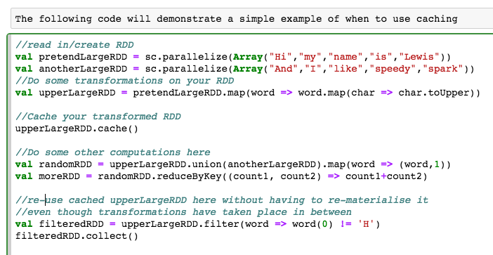

------------------------------------------------------------------------------------------

**Note** : Above example Map function is used with in a Map function to apply toUpper function as this function works on character

Alternate is toUpperCase, this works on string.

**Program : Usage of toUpper**

val b = sc.parallelize(Array("and", "I", "Like", "Speeky", "spark"))

val uppera = a.map(word => word.toUpper) 🡺 Does not work

val uppera = a.map(word => word.map(char => char.toUpper) 🡺 Works.. Map is used with Map function

uppera.take(10)

**Output:**

res0: Array[String] = Array(HI, MY, NAME, IS, LEWIS)

**Program : Usage of toUpperCase**

val uppera = a.map(word => word.toUpperCase);

uppera.take(10)

**Output:**

res1: Array[String] = Array(HI, MY, NAME, IS, LEWIS)

------------------------------------------------------------------------------------------

By simply caching the RDD I can happily re-use it for some later transformations without having to rebuild it from scratch.

RDDs can be cached in memory (by default) or persisted to disk. You would choose the persistence level based on your use case and the size of the RDD. Full details on parameters can be found [here](http://spark.apache.org/docs/latest/programming-guide.html#rdd-persistence)

If you are in a noisey cluster, checkpointing may also help to store RDD’s to files within HDFS saving memory. Otherwise it is recommended to only use checkpoints when your RDD lineage gets too large. It is important that you persist/cache your RDD first before checkpointing as checkpointing will materialise the RDD twice, once when it builds it for use and again when it needs to write it to disk - however if you have cached it before hand, it only needs to materialise it once, the second time it can read from the cache.

**So whats the difference between checkpoints and using persist(DISK_ONLY) I hear you ask?** Great question! The answer is simple - persisting will materialise and save the RDD in memory or disk or both depending on your configuration and will also **store and remember the lineage**. This means that if there are Node failures on the node storing your cached RDD, they can be rebuilt using the lineage. Checkpoints **do not store the lineage** and will only write RDD contents to disk.

## 2. Skewed Keys

Holden used the term Key skewing to describe the challenge when keys aren’t evenly distributed. Key skewing can lead to unbalanced partitions meaning that transformations wont be distributed well meaning they can take longer to run. Null records are something that can cause key skewing, especially if they are frequent.

GroupByKey() in particular doesn’t work well when keys are skewed, however it is an inefficient operation for many other reasons.

To prevent key skewing from nulls, you can try filtering out nulls as early on as possible in your dataset. If this isnt possible then add some extra junk to your key to help the distribution. This technique will then allow for a more random nature for keys meaning they are better distributed. This is an important part of how HBase works. HBase architects always recommend concatenating multiple columns to create keys or hashing values if you cannot guarentee randomness.

SortByKey suffers from similar issues as all data for a key goes to the same node. If your keys are skewed a high percentaged of your data could end up going to one node and filling it. Again, you can simply add some extra junk to the key to help distribute it better and prevent this from happening.

## 3. The evil Group By Key

GroupByKey groups all records with the same key into a single record - but this is what you want and expected right?

The catch is that it will do this even if we want to immediately reduce or sum on this RDD afterwards. In addition, this single record - especially for wide data sets - can be too big to fit in memory and then cause your application to fail - disaster!

To overcome this ReduceByKey() allows map side reduction and therefore doesn’t make a super large single record. It will also reduce the data locally before distributing it across the network again boosting its efficiency.

## 4. Spark SQL and DataFrames to the rescue

DataFrames are more efficient than RDD’s in many use cases for a number of reasons. Firstly, non JVM users using Python or R should use DataFrames. This is because DataFrames allow Spark to manage the schema and only pass data between nodes. This is more efficient than Java serialization. DataFrames use serialization to their benefit when performing transformations that are large within a single process. They can essentially write data outside of the heap memory and still perform transformations on this data avoiding the garbage collection overhead.

DataFrames also have their own optimizer that is able to look inside operations. Regular spark can’t do this - Holden’s example stated that it wouldn’t know the difference between (min(_,_)) and (append(_,_)).

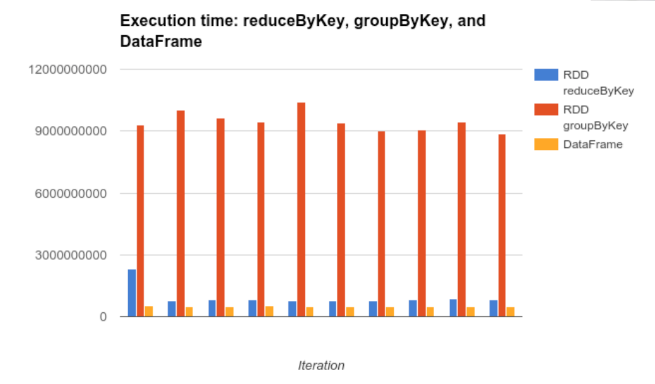

Image copied from*[holden](http://www.slideshare.net/hkarau/beyond-shuffling-strata-london-2016)*

Beware though, they aren’t perfect. They won’t perform well for iterative algorithms and large lineage plans. To avoid this you can simply convert your datafrom to an RDD using toRDD, perform myRDD.cache() then convert it back to a DataFrame using toDF. Finally, The default shuffle size of 200 partitions can also be too small for large computations so you may find in certain use cases that you would need to manually increase this.

## 5. Datasets are the future.

Datasets are the new DataFrames. In fact, they are an extension of the DataFrame API. The API is familiar making it very easy to use and the list of benefits in terms of performance is huge. Datasets have a simpler API, execute faster and have a lower memory overhead in comparison to RDD’s.

They are able to execute faster as Datasets use something called encoders to translate between JVM objects and Sparks binary format. These same encoders allow transformations to be applied to seralized data removing the lag of having to deserialize objects all the time.

These same encoders describe the underlying data structures allowing Spark to optimally store the data in memory when caching. This means that the memory overhead is heavily descreased and will subsiquently improve performance too. Databricks have a great intro [article](https://databricks.com/blog/2016/01/04/introducing-apache-spark-datasets.html) outlining all the benefits Datasets bring.

Seeing as the API is familiar, changing over from RDD’s to Datasets is really a no brainer if you’re looking to optimize your code.